**COMP 8006 Set 5D**

**Assignment 2: Building A Personal Linux Firewall**

**29 Jan 2015**

**Thilina Ratnayake**

**A00802338**

**Table Of Contents:**

|  |  |
| --- | --- |
| Page | Item |
| 3 | Objective |
| 4 | **Program Structure** |
| 4 | Program Components |
| 5 | Firewall Design |
| 5 | Psuedo Code |
| 6 | Execution Instructions |
| 7 | **Tests** |
| 8 | Data & Results |

**Objective:**  To implement and test a simple personal Linux Firewall.

**Program Structure:**

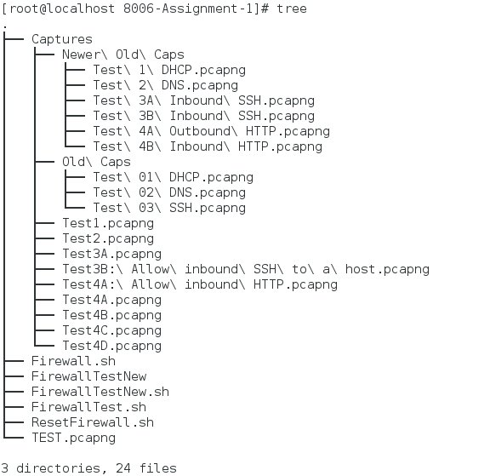

**Program Components:**

1. **Firewall.sh** – BASH Script that adds rules to IPtables
2. **ResetFirewall.sh** – BASH Script that deletes all rules from IPtables and restores computer to lab default settings (e.g. All chains ALLOW)
3. **FirewallTest.sh –** BASH Script that automates the tests by performing HPINGS and opening wireshark windows at appropriate intervals.

**Firewall Design:**

1. Default policy of dropping everything unless stated other was invoked.
2. 12 chains were made, all representing an IN or OUT rule. The decision to use specific IN/OUT chains (e.g. SSH IN and SSH OUT versus SSHTRAFFIC) was made because it is much easier to view statistics at a glance and spot issues. (e.g. looking at SSHTRAFFIC during a DOS attack and not knowing where the problem lay)
3. More specific rules (like dropping all traffic going to or coming from a reserved port like 0) were put earlier in the firewall than later. This is because as a defense mechanism, we want to neutralize serious threats first and let our “catch-all” rules deal with all that get through.

Psuedo Code (Firewall.sh) :

1. Make all the chains
2. Route the chains to appropriate functions (ACCEPT or DROP)
3. Create the rules and route to chain
   1. Add the really specific rules first (e.g. Drop ALL /FROM port 0)
   2. Broader rules near bottom.
4. RESET THE FIREWALL/IPTABLES WHEN SCRIPT IS FINISHED.

Psuedo Code (FirewallTest.sh):

1. Prompt user for all necessary info (e.g. Remote workstation ip, ssh user, password)
2. Test DHCP connectivity
   1. DHCP release
   2. DHCP renew
   3. Check Wireshark
   4. Check that mchine has IP
3. Test DNS connectivity
   1. NSlookup [www.google.com](http://www.google.com)
   2. Check wireshark
4. Test SSH connectivity
   1. Check outbound by SSH’ing into remote terminal
   2. Check wireshark
   3. Check inbound by first SSH’ing into remote and sending HPing’s on SSH port to local.
5. Test dropping packet 0
   1. HPing remote with src port 0 (check for failure)
   2. HPing remote with dest port 0 (check for failure)
   3. Try the same from remote to local
   4. Try from NON port 0’s (check for success)
   5. Check wireshark captures
6. Test Denied HTTP
   1. SSH into remote
   2. Try to access local with port in range 1-1024 (check for failure)
   3. Check wireshark
   4. Check with port OUTSIDE of range (check for success)
   5. Test HTTP
      1. Outgoing: Check any normal website (hping google.com)
      2. Outgoing: SSH into remote, start Apache, hping
      3. Incoming: Check that HPing’s get returned
      4. Incoming: Start apache, try hpingining from remote
      5. Check wrieshark

**Execution Instructions:**

Run sh.FirewallTest.sh

**Tests:**

|  |  |  |  |  |  |  |  |  |  |
| --- | --- | --- | --- | --- | --- | --- | --- | --- | --- |
| # | Rule | Direction | Source Port | Destination Port | Test | Wireshark Screenshot | Capture Name | Expected | Result |
| 1 | Permit DHCP | Out |  | 68 | dhclient -r dhclient | Fig 1 | Test1.pcapng | Passed | As expected |
| 2 | Permit DHCP | In | 68 |  | Fig 1 | Test1.pcapng | Passed | As expected |
| 3 | Permit DNS | Out |  | 53 | nslookup www.google.com | Fig 2 | Test2.pcapng | Passed | As expected |
| 4 | Permit DNS | In | 53 |  | Fig 2 | Test2.pcapng | Passed | As expected |
| 5 | Permit SSH connections Out | Out |  | 22 | SSH into remote machine | Fig 3.1 | Test 3A.pcapng | Passed | As expected |
| 6 | Permit SSH replies In | In |  | 22 | Fig 3.1 | Test 3A.pcapng | Passed | As expected |
| 7 | Permit SSH connections In | In | 22 |  | Let remote machine SSH into local | Fig 3.2 | Test 3B.pcapng | Passed | As expected |
| 8 | Permit SSH replies Out | Out | 22 |  | Fig 3.2 | Test 3B.pcapng | Passed | As expected |
| 9 | Drop all incoming traffic from port 0 | IN | 0 |  | Remote machine:  hping3 LOCAL -S -s 0 -p 80 | Fig 4.1 | Test 4A.pcapng | Dropped | As expected |
| 11 | Drop all outgoing traffic to port 0 | Out |  | 0 | Local machine: hping3 REMOTE -S -s 90 -p 0 | Fig 4.2 | - | Dropped | As expected |
|  | Drop inbound traffic to port 80 from select ports | IN | 1-1024 | 80 | Remote machine: hping3 LOCAL -S -s 1019 -p 80 | Fig 5.1 | Test 5A.pcapng | As expected |  |
|  | Allow outbound HTTP | Out |  | 80 | Local machine: hping3 www.tratnayake.me -s 600 -p 80 | Fig 6.1 | Test 6A.pcapng | As expected |  |
|  | Allow inbound HTTP replies | IN | 80 |  | Remote machine: hping3 LOCAL -S -s 80 -p 650 | Fig 6.1 | Test 6A.pcapng | As expected |  |
|  | Allow inbound HTTP connections (to Apache) | IN |  | 80 | Remote machine: hping3 LOCAL -S -s 2000 -p 80 | Fig 6.2 | Test 6A.pcapng | As expected |  |
|  | Allow outbound HTTP replies (from Apache) | Out | 80 |  | Local machine: hping3 Remote -S -s 80 -p 2000 | Fig 6.2 | Test 6A.pcapng | As expected |  |

**Screenshots**



**Fig1 – Evidence of DHCP**

**Fig 2: Evidence of DNS**

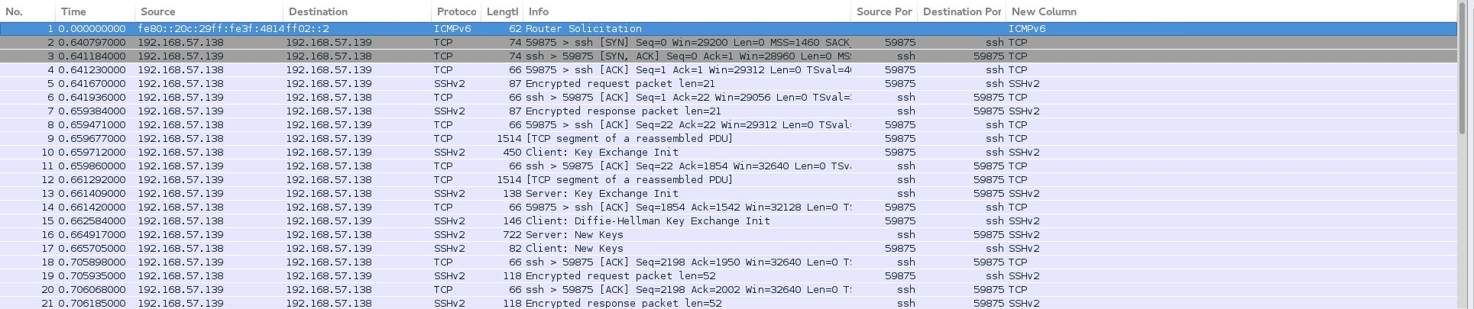

**Fig 3.1: Outgoing SSH connection to a remote host.**

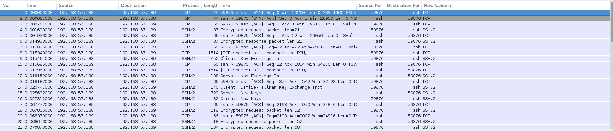

**Figure 3.2 – Incoming SSH connection and replies**

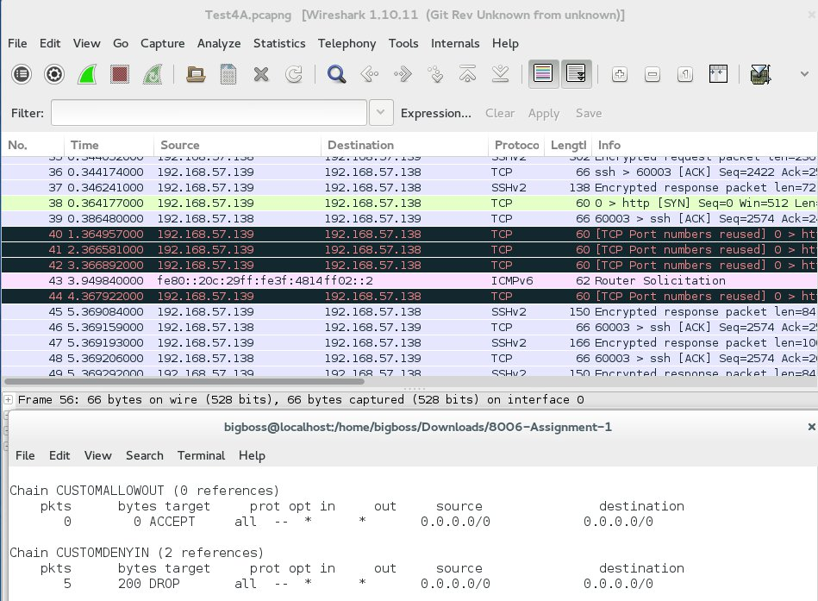

**Fig 4.1: Custom drop from 0 rule dropping 5 packets.**

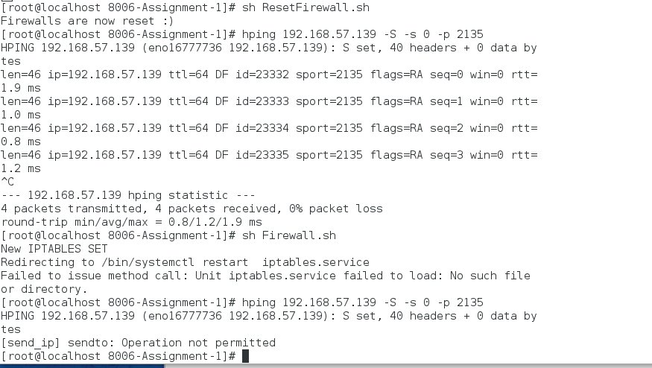

**Fig 4.2** Custom rule denying ability to send packets TO port 0

f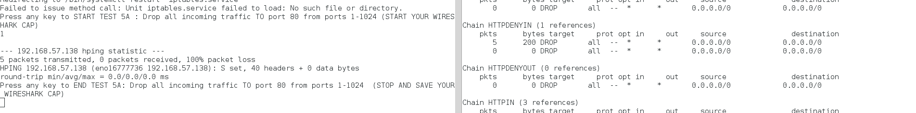

**Fig 5.1:** Deny packets to port 80 from source port 1-1023

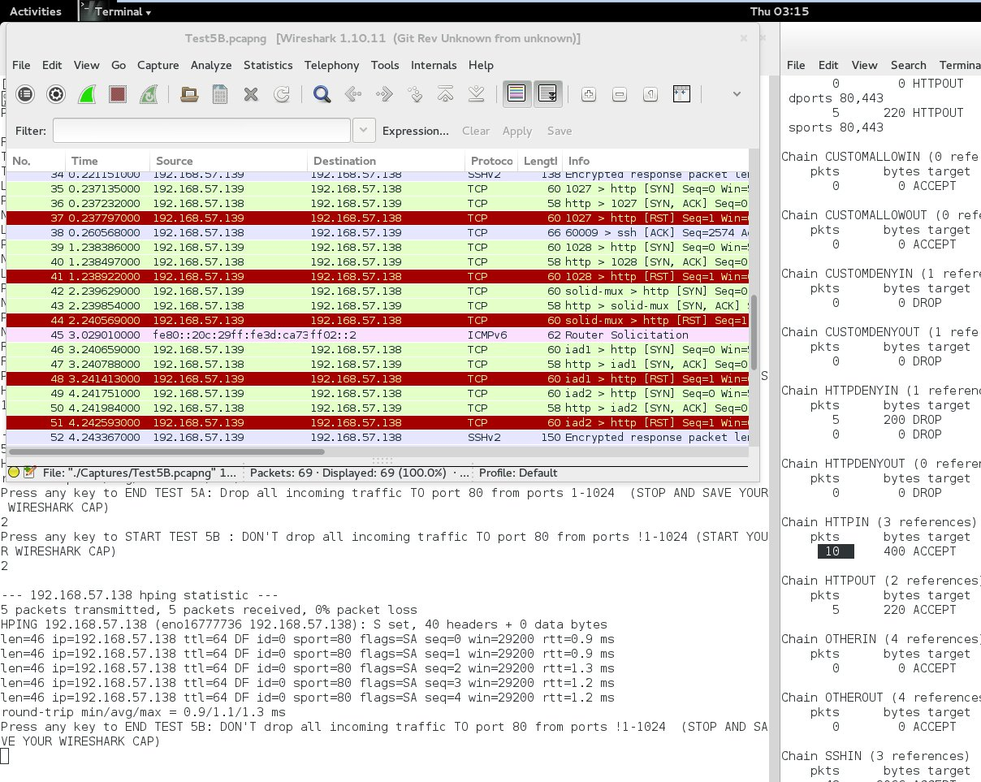

**Fig 5.2: Allowing traffic from ports !1-1024 into port 80**

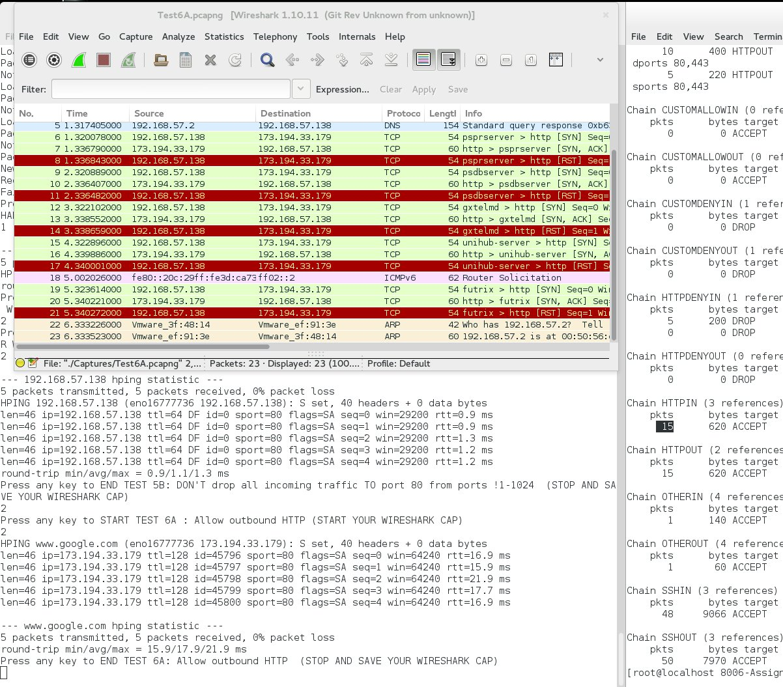

**Fig 6.1: Allow outbound HTTP**

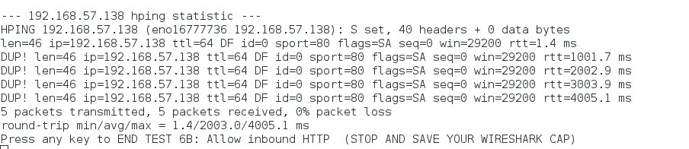

**Fig 6.2: Allowing inbound HTTP (screenshot taken from an SSH session pinging LOCAL machine)**

**Fig 7. Log file containing test by test comparison of iptables and packets allowed or dropped by chains.**

*Format is:*

*START TEST X*

*--tables—*

*END TEXT X*

*--tables—*

**Notable occurences are highlighted.**

**START Test 1 : Allow Inbound/Outbound DHCP**

Chain INPUT (policy DROP 0 packets, 0 bytes)

pkts bytes target prot opt in out source destination

0 0 OTHERIN udp -- * * 0.0.0.0/0 0.0.0.0/0 udp spt:53

0 0 OTHERIN tcp -- * * 0.0.0.0/0 0.0.0.0/0 tcp spt:53

0 0 OTHERIN udp -- * * 0.0.0.0/0 0.0.0.0/0 udp spt:68

0 0 OTHERIN tcp -- * * 0.0.0.0/0 0.0.0.0/0 tcp spt:68

0 0 SSHIN tcp -- * * 0.0.0.0/0 0.0.0.0/0 tcp dpt:22

0 0 SSHIN tcp -- * * 0.0.0.0/0 0.0.0.0/0 tcp spt:22

0 0 SSHIN udp -- * * 0.0.0.0/0 0.0.0.0/0 udp dpt:22

0 0 CUSTOMDENYIN tcp -- * * 0.0.0.0/0 0.0.0.0/0 tcp spt:0

0 0 HTTPIN tcp -- * * 0.0.0.0/0 0.0.0.0/0 tcp spts:!1:1023 dpt:80

0 0 HTTPDENYIN tcp -- * * 0.0.0.0/0 0.0.0.0/0 tcp spts:1:1023 dpt:80

0 0 HTTPIN tcp -- * * 0.0.0.0/0 0.0.0.0/0 multiport sports 80,443

0 0 HTTPIN tcp -- * * 0.0.0.0/0 0.0.0.0/0 multiport dports 80,443

Chain FORWARD (policy DROP 0 packets, 0 bytes)

pkts bytes target prot opt in out source destination

Chain OUTPUT (policy DROP 0 packets, 0 bytes)

pkts bytes target prot opt in out source destination

0 0 OTHEROUT udp -- * * 0.0.0.0/0 0.0.0.0/0 udp dpt:53

0 0 OTHEROUT tcp -- * * 0.0.0.0/0 0.0.0.0/0 tcp dpt:53

0 0 OTHEROUT udp -- * * 0.0.0.0/0 0.0.0.0/0 udp dpt:68

0 0 OTHEROUT tcp -- * * 0.0.0.0/0 0.0.0.0/0 tcp dpt:68

0 0 SSHOUT tcp -- * * 0.0.0.0/0 0.0.0.0/0 tcp spt:22

0 0 SSHOUT tcp -- * * 0.0.0.0/0 0.0.0.0/0 tcp dpt:22

0 0 SSHOUT udp -- * * 0.0.0.0/0 0.0.0.0/0 udp dpt:22

0 0 CUSTOMDENYOUT tcp -- * * 0.0.0.0/0 0.0.0.0/0 tcp dpt:0

0 0 HTTPOUT tcp -- * * 0.0.0.0/0 0.0.0.0/0 multiport dports 80,443

0 0 HTTPOUT tcp -- * * 0.0.0.0/0 0.0.0.0/0 multiport sports 80,443

Chain CUSTOMALLOWIN (0 references)

pkts bytes target prot opt in out source destination

0 0 ACCEPT all -- * * 0.0.0.0/0 0.0.0.0/0

Chain CUSTOMALLOWOUT (0 references)

pkts bytes target prot opt in out source destination

0 0 ACCEPT all -- * * 0.0.0.0/0 0.0.0.0/0

Chain CUSTOMDENYIN (1 references)

pkts bytes target prot opt in out source destination

0 0 DROP all -- * * 0.0.0.0/0 0.0.0.0/0

Chain CUSTOMDENYOUT (1 references)

pkts bytes target prot opt in out source destination

0 0 DROP all -- * * 0.0.0.0/0 0.0.0.0/0

Chain HTTPDENYIN (1 references)

pkts bytes target prot opt in out source destination

0 0 DROP all -- * * 0.0.0.0/0 0.0.0.0/0

0 0 DROP all -- * * 0.0.0.0/0 0.0.0.0/0

Chain HTTPDENYOUT (0 references)

pkts bytes target prot opt in out source destination

0 0 DROP all -- * * 0.0.0.0/0 0.0.0.0/0

Chain HTTPIN (3 references)

pkts bytes target prot opt in out source destination

0 0 ACCEPT all -- * * 0.0.0.0/0 0.0.0.0/0

Chain HTTPOUT (2 references)

pkts bytes target prot opt in out source destination

0 0 ACCEPT all -- * * 0.0.0.0/0 0.0.0.0/0

Chain OTHERIN (4 references)

pkts bytes target prot opt in out source destination

0 0 ACCEPT all -- * * 0.0.0.0/0 0.0.0.0/0

Chain OTHEROUT (4 references)

pkts bytes target prot opt in out source destination

0 0 ACCEPT all -- * * 0.0.0.0/0 0.0.0.0/0

Chain SSHIN (3 references)

pkts bytes target prot opt in out source destination

0 0 ACCEPT all -- * * 0.0.0.0/0 0.0.0.0/0

Chain SSHOUT (3 references)

pkts bytes target prot opt in out source destination

0 0 ACCEPT all -- * * 0.0.0.0/0 0.0.0.0/0

**END Test 1: Allow Inbound/Outbound DHCP**

Chain INPUT (policy DROP 0 packets, 0 bytes)

pkts bytes target prot opt in out source destination

1 122 OTHERIN udp -- * * 0.0.0.0/0 0.0.0.0/0 udp spt:53

0 0 OTHERIN tcp -- * * 0.0.0.0/0 0.0.0.0/0 tcp spt:53

0 0 OTHERIN udp -- * * 0.0.0.0/0 0.0.0.0/0 udp spt:68

0 0 OTHERIN tcp -- * * 0.0.0.0/0 0.0.0.0/0 tcp spt:68

0 0 SSHIN tcp -- * * 0.0.0.0/0 0.0.0.0/0 tcp dpt:22

0 0 SSHIN tcp -- * * 0.0.0.0/0 0.0.0.0/0 tcp spt:22

0 0 SSHIN udp -- * * 0.0.0.0/0 0.0.0.0/0 udp dpt:22

0 0 CUSTOMDENYIN tcp -- * * 0.0.0.0/0 0.0.0.0/0 tcp spt:0

0 0 HTTPIN tcp -- * * 0.0.0.0/0 0.0.0.0/0 tcp spts:!1:1023 dpt:80

0 0 HTTPDENYIN tcp -- * * 0.0.0.0/0 0.0.0.0/0 tcp spts:1:1023 dpt:80

0 0 HTTPIN tcp -- * * 0.0.0.0/0 0.0.0.0/0 multiport sports 80,443

0 0 HTTPIN tcp -- * * 0.0.0.0/0 0.0.0.0/0 multiport dports 80,443

Chain FORWARD (policy DROP 0 packets, 0 bytes)

pkts bytes target prot opt in out source destination

Chain OUTPUT (policy DROP 15 packets, 3106 bytes)

pkts bytes target prot opt in out source destination

1 73 OTHEROUT udp -- * * 0.0.0.0/0 0.0.0.0/0 udp dpt:53

0 0 OTHEROUT tcp -- * * 0.0.0.0/0 0.0.0.0/0 tcp dpt:53

0 0 OTHEROUT udp -- * * 0.0.0.0/0 0.0.0.0/0 udp dpt:68

0 0 OTHEROUT tcp -- * * 0.0.0.0/0 0.0.0.0/0 tcp dpt:68

0 0 SSHOUT tcp -- * * 0.0.0.0/0 0.0.0.0/0 tcp spt:22

0 0 SSHOUT tcp -- * * 0.0.0.0/0 0.0.0.0/0 tcp dpt:22

0 0 SSHOUT udp -- * * 0.0.0.0/0 0.0.0.0/0 udp dpt:22

0 0 CUSTOMDENYOUT tcp -- * * 0.0.0.0/0 0.0.0.0/0 tcp dpt:0

0 0 HTTPOUT tcp -- * * 0.0.0.0/0 0.0.0.0/0 multiport dports 80,443

0 0 HTTPOUT tcp -- * * 0.0.0.0/0 0.0.0.0/0 multiport sports 80,443

Chain CUSTOMALLOWIN (0 references)

pkts bytes target prot opt in out source destination

0 0 ACCEPT all -- * * 0.0.0.0/0 0.0.0.0/0

Chain CUSTOMALLOWOUT (0 references)

pkts bytes target prot opt in out source destination

0 0 ACCEPT all -- * * 0.0.0.0/0 0.0.0.0/0

Chain CUSTOMDENYIN (1 references)

pkts bytes target prot opt in out source destination

0 0 DROP all -- * * 0.0.0.0/0 0.0.0.0/0

Chain CUSTOMDENYOUT (1 references)

pkts bytes target prot opt in out source destination

0 0 DROP all -- * * 0.0.0.0/0 0.0.0.0/0

Chain HTTPDENYIN (1 references)

pkts bytes target prot opt in out source destination

0 0 DROP all -- * * 0.0.0.0/0 0.0.0.0/0

0 0 DROP all -- * * 0.0.0.0/0 0.0.0.0/0

Chain HTTPDENYOUT (0 references)

pkts bytes target prot opt in out source destination

0 0 DROP all -- * * 0.0.0.0/0 0.0.0.0/0

Chain HTTPIN (3 references)

pkts bytes target prot opt in out source destination

0 0 ACCEPT all -- * * 0.0.0.0/0 0.0.0.0/0

Chain HTTPOUT (2 references)

pkts bytes target prot opt in out source destination

0 0 ACCEPT all -- * * 0.0.0.0/0 0.0.0.0/0

Chain OTHERIN (4 references)

pkts bytes target prot opt in out source destination

1 122 ACCEPT all -- * * 0.0.0.0/0 0.0.0.0/0

Chain OTHEROUT (4 references)

pkts bytes target prot opt in out source destination

1 73 ACCEPT all -- * * 0.0.0.0/0 0.0.0.0/0

Chain SSHIN (3 references)

pkts bytes target prot opt in out source destination

0 0 ACCEPT all -- * * 0.0.0.0/0 0.0.0.0/0

Chain SSHOUT (3 references)

pkts bytes target prot opt in out source destination

0 0 ACCEPT all -- * * 0.0.0.0/0 0.0.0.0/0

**START Test 2 : Allow Inbound/Outbound DNS**

Chain INPUT (policy DROP 0 packets, 0 bytes)

pkts bytes target prot opt in out source destination

1 122 OTHERIN udp -- * * 0.0.0.0/0 0.0.0.0/0 udp spt:53

0 0 OTHERIN tcp -- * * 0.0.0.0/0 0.0.0.0/0 tcp spt:53

0 0 OTHERIN udp -- * * 0.0.0.0/0 0.0.0.0/0 udp spt:68

0 0 OTHERIN tcp -- * * 0.0.0.0/0 0.0.0.0/0 tcp spt:68

0 0 SSHIN tcp -- * * 0.0.0.0/0 0.0.0.0/0 tcp dpt:22

0 0 SSHIN tcp -- * * 0.0.0.0/0 0.0.0.0/0 tcp spt:22

0 0 SSHIN udp -- * * 0.0.0.0/0 0.0.0.0/0 udp dpt:22

0 0 CUSTOMDENYIN tcp -- * * 0.0.0.0/0 0.0.0.0/0 tcp spt:0

0 0 HTTPIN tcp -- * * 0.0.0.0/0 0.0.0.0/0 tcp spts:!1:1023 dpt:80

0 0 HTTPDENYIN tcp -- * * 0.0.0.0/0 0.0.0.0/0 tcp spts:1:1023 dpt:80

0 0 HTTPIN tcp -- * * 0.0.0.0/0 0.0.0.0/0 multiport sports 80,443

0 0 HTTPIN tcp -- * * 0.0.0.0/0 0.0.0.0/0 multiport dports 80,443

Chain FORWARD (policy DROP 0 packets, 0 bytes)

pkts bytes target prot opt in out source destination

Chain OUTPUT (policy DROP 16 packets, 3146 bytes)

pkts bytes target prot opt in out source destination

1 73 OTHEROUT udp -- * * 0.0.0.0/0 0.0.0.0/0 udp dpt:53

0 0 OTHEROUT tcp -- * * 0.0.0.0/0 0.0.0.0/0 tcp dpt:53

0 0 OTHEROUT udp -- * * 0.0.0.0/0 0.0.0.0/0 udp dpt:68

0 0 OTHEROUT tcp -- * * 0.0.0.0/0 0.0.0.0/0 tcp dpt:68

0 0 SSHOUT tcp -- * * 0.0.0.0/0 0.0.0.0/0 tcp spt:22

0 0 SSHOUT tcp -- * * 0.0.0.0/0 0.0.0.0/0 tcp dpt:22

0 0 SSHOUT udp -- * * 0.0.0.0/0 0.0.0.0/0 udp dpt:22

0 0 CUSTOMDENYOUT tcp -- * * 0.0.0.0/0 0.0.0.0/0 tcp dpt:0

0 0 HTTPOUT tcp -- * * 0.0.0.0/0 0.0.0.0/0 multiport dports 80,443

0 0 HTTPOUT tcp -- * * 0.0.0.0/0 0.0.0.0/0 multiport sports 80,443

Chain CUSTOMALLOWIN (0 references)

pkts bytes target prot opt in out source destination

0 0 ACCEPT all -- * * 0.0.0.0/0 0.0.0.0/0

Chain CUSTOMALLOWOUT (0 references)

pkts bytes target prot opt in out source destination

0 0 ACCEPT all -- * * 0.0.0.0/0 0.0.0.0/0

Chain CUSTOMDENYIN (1 references)

pkts bytes target prot opt in out source destination

0 0 DROP all -- * * 0.0.0.0/0 0.0.0.0/0

Chain CUSTOMDENYOUT (1 references)

pkts bytes target prot opt in out source destination

0 0 DROP all -- * * 0.0.0.0/0 0.0.0.0/0

Chain HTTPDENYIN (1 references)

pkts bytes target prot opt in out source destination

0 0 DROP all -- * * 0.0.0.0/0 0.0.0.0/0

0 0 DROP all -- * * 0.0.0.0/0 0.0.0.0/0

Chain HTTPDENYOUT (0 references)

pkts bytes target prot opt in out source destination

0 0 DROP all -- * * 0.0.0.0/0 0.0.0.0/0

Chain HTTPIN (3 references)

pkts bytes target prot opt in out source destination

0 0 ACCEPT all -- * * 0.0.0.0/0 0.0.0.0/0

Chain HTTPOUT (2 references)

pkts bytes target prot opt in out source destination

0 0 ACCEPT all -- * * 0.0.0.0/0 0.0.0.0/0

Chain OTHERIN (4 references)

pkts bytes target prot opt in out source destination

1 122 ACCEPT all -- * * 0.0.0.0/0 0.0.0.0/0

Chain OTHEROUT (4 references)

pkts bytes target prot opt in out source destination

1 73 ACCEPT all -- * * 0.0.0.0/0 0.0.0.0/0

Chain SSHIN (3 references)

pkts bytes target prot opt in out source destination

0 0 ACCEPT all -- * * 0.0.0.0/0 0.0.0.0/0

Chain SSHOUT (3 references)

pkts bytes target prot opt in out source destination

0 0 ACCEPT all -- * * 0.0.0.0/0 0.0.0.0/0

**END Test 2: Allow Inbound/Outbound DNS**

Chain INPUT (policy DROP 0 packets, 0 bytes)

pkts bytes target prot opt in out source destination

2 312 OTHERIN udp -- * * 0.0.0.0/0 0.0.0.0/0 udp spt:53

0 0 OTHERIN tcp -- * * 0.0.0.0/0 0.0.0.0/0 tcp spt:53

0 0 OTHERIN udp -- * * 0.0.0.0/0 0.0.0.0/0 udp spt:68

0 0 OTHERIN tcp -- * * 0.0.0.0/0 0.0.0.0/0 tcp spt:68

0 0 SSHIN tcp -- * * 0.0.0.0/0 0.0.0.0/0 tcp dpt:22

0 0 SSHIN tcp -- * * 0.0.0.0/0 0.0.0.0/0 tcp spt:22

0 0 SSHIN udp -- * * 0.0.0.0/0 0.0.0.0/0 udp dpt:22

0 0 CUSTOMDENYIN tcp -- * * 0.0.0.0/0 0.0.0.0/0 tcp spt:0

0 0 HTTPIN tcp -- * * 0.0.0.0/0 0.0.0.0/0 tcp spts:!1:1023 dpt:80

0 0 HTTPDENYIN tcp -- * * 0.0.0.0/0 0.0.0.0/0 tcp spts:1:1023 dpt:80

0 0 HTTPIN tcp -- * * 0.0.0.0/0 0.0.0.0/0 multiport sports 80,443

0 0 HTTPIN tcp -- * * 0.0.0.0/0 0.0.0.0/0 multiport dports 80,443

Chain FORWARD (policy DROP 0 packets, 0 bytes)

pkts bytes target prot opt in out source destination

Chain OUTPUT (policy DROP 16 packets, 3146 bytes)

pkts bytes target prot opt in out source destination

2 135 OTHEROUT udp -- * * 0.0.0.0/0 0.0.0.0/0 udp dpt:53

0 0 OTHEROUT tcp -- * * 0.0.0.0/0 0.0.0.0/0 tcp dpt:53

0 0 OTHEROUT udp -- * * 0.0.0.0/0 0.0.0.0/0 udp dpt:68

0 0 OTHEROUT tcp -- * * 0.0.0.0/0 0.0.0.0/0 tcp dpt:68

0 0 SSHOUT tcp -- * * 0.0.0.0/0 0.0.0.0/0 tcp spt:22

0 0 SSHOUT tcp -- * * 0.0.0.0/0 0.0.0.0/0 tcp dpt:22

0 0 SSHOUT udp -- * * 0.0.0.0/0 0.0.0.0/0 udp dpt:22

0 0 CUSTOMDENYOUT tcp -- * * 0.0.0.0/0 0.0.0.0/0 tcp dpt:0

0 0 HTTPOUT tcp -- * * 0.0.0.0/0 0.0.0.0/0 multiport dports 80,443

0 0 HTTPOUT tcp -- * * 0.0.0.0/0 0.0.0.0/0 multiport sports 80,443

Chain CUSTOMALLOWIN (0 references)

pkts bytes target prot opt in out source destination

0 0 ACCEPT all -- * * 0.0.0.0/0 0.0.0.0/0

Chain CUSTOMALLOWOUT (0 references)

pkts bytes target prot opt in out source destination

0 0 ACCEPT all -- * * 0.0.0.0/0 0.0.0.0/0

Chain CUSTOMDENYIN (1 references)

pkts bytes target prot opt in out source destination

0 0 DROP all -- * * 0.0.0.0/0 0.0.0.0/0

Chain CUSTOMDENYOUT (1 references)

pkts bytes target prot opt in out source destination

0 0 DROP all -- * * 0.0.0.0/0 0.0.0.0/0

Chain HTTPDENYIN (1 references)

pkts bytes target prot opt in out source destination

0 0 DROP all -- * * 0.0.0.0/0 0.0.0.0/0

0 0 DROP all -- * * 0.0.0.0/0 0.0.0.0/0

Chain HTTPDENYOUT (0 references)

pkts bytes target prot opt in out source destination

0 0 DROP all -- * * 0.0.0.0/0 0.0.0.0/0

Chain HTTPIN (3 references)

pkts bytes target prot opt in out source destination

0 0 ACCEPT all -- * * 0.0.0.0/0 0.0.0.0/0

Chain HTTPOUT (2 references)

pkts bytes target prot opt in out source destination

0 0 ACCEPT all -- * * 0.0.0.0/0 0.0.0.0/0

Chain OTHERIN (4 references)

pkts bytes target prot opt in out source destination

2 312 ACCEPT all -- * * 0.0.0.0/0 0.0.0.0/0

Chain OTHEROUT (4 references)

pkts bytes target prot opt in out source destination

2 135 ACCEPT all -- * * 0.0.0.0/0 0.0.0.0/0

Chain SSHIN (3 references)

pkts bytes target prot opt in out source destination

0 0 ACCEPT all -- * * 0.0.0.0/0 0.0.0.0/0

Chain SSHOUT (3 references)

pkts bytes target prot opt in out source destination

0 0 ACCEPT all -- * * 0.0.0.0/0 0.0.0.0/0

**START Test 3A : Allow outbound SSH to a host**

Chain INPUT (policy DROP 0 packets, 0 bytes)

pkts bytes target prot opt in out source destination

2 312 OTHERIN udp -- * * 0.0.0.0/0 0.0.0.0/0 udp spt:53

0 0 OTHERIN tcp -- * * 0.0.0.0/0 0.0.0.0/0 tcp spt:53

0 0 OTHERIN udp -- * * 0.0.0.0/0 0.0.0.0/0 udp spt:68

0 0 OTHERIN tcp -- * * 0.0.0.0/0 0.0.0.0/0 tcp spt:68

0 0 SSHIN tcp -- * * 0.0.0.0/0 0.0.0.0/0 tcp dpt:22

0 0 SSHIN tcp -- * * 0.0.0.0/0 0.0.0.0/0 tcp spt:22

0 0 SSHIN udp -- * * 0.0.0.0/0 0.0.0.0/0 udp dpt:22

0 0 CUSTOMDENYIN tcp -- * * 0.0.0.0/0 0.0.0.0/0 tcp spt:0

0 0 HTTPIN tcp -- * * 0.0.0.0/0 0.0.0.0/0 tcp spts:!1:1023 dpt:80

0 0 HTTPDENYIN tcp -- * * 0.0.0.0/0 0.0.0.0/0 tcp spts:1:1023 dpt:80

0 0 HTTPIN tcp -- * * 0.0.0.0/0 0.0.0.0/0 multiport sports 80,443

0 0 HTTPIN tcp -- * * 0.0.0.0/0 0.0.0.0/0 multiport dports 80,443

Chain FORWARD (policy DROP 0 packets, 0 bytes)

pkts bytes target prot opt in out source destination

Chain OUTPUT (policy DROP 16 packets, 3146 bytes)

pkts bytes target prot opt in out source destination

2 135 OTHEROUT udp -- * * 0.0.0.0/0 0.0.0.0/0 udp dpt:53

0 0 OTHEROUT tcp -- * * 0.0.0.0/0 0.0.0.0/0 tcp dpt:53

0 0 OTHEROUT udp -- * * 0.0.0.0/0 0.0.0.0/0 udp dpt:68

0 0 OTHEROUT tcp -- * * 0.0.0.0/0 0.0.0.0/0 tcp dpt:68

0 0 SSHOUT tcp -- * * 0.0.0.0/0 0.0.0.0/0 tcp spt:22

0 0 SSHOUT tcp -- * * 0.0.0.0/0 0.0.0.0/0 tcp dpt:22

0 0 SSHOUT udp -- * * 0.0.0.0/0 0.0.0.0/0 udp dpt:22

0 0 CUSTOMDENYOUT tcp -- * * 0.0.0.0/0 0.0.0.0/0 tcp dpt:0

0 0 HTTPOUT tcp -- * * 0.0.0.0/0 0.0.0.0/0 multiport dports 80,443

0 0 HTTPOUT tcp -- * * 0.0.0.0/0 0.0.0.0/0 multiport sports 80,443

Chain CUSTOMALLOWIN (0 references)

pkts bytes target prot opt in out source destination

0 0 ACCEPT all -- * * 0.0.0.0/0 0.0.0.0/0

Chain CUSTOMALLOWOUT (0 references)

pkts bytes target prot opt in out source destination

0 0 ACCEPT all -- * * 0.0.0.0/0 0.0.0.0/0

Chain CUSTOMDENYIN (1 references)

pkts bytes target prot opt in out source destination

0 0 DROP all -- * * 0.0.0.0/0 0.0.0.0/0

Chain CUSTOMDENYOUT (1 references)

pkts bytes target prot opt in out source destination

0 0 DROP all -- * * 0.0.0.0/0 0.0.0.0/0

Chain HTTPDENYIN (1 references)

pkts bytes target prot opt in out source destination

0 0 DROP all -- * * 0.0.0.0/0 0.0.0.0/0

0 0 DROP all -- * * 0.0.0.0/0 0.0.0.0/0

Chain HTTPDENYOUT (0 references)

pkts bytes target prot opt in out source destination

0 0 DROP all -- * * 0.0.0.0/0 0.0.0.0/0

Chain HTTPIN (3 references)

pkts bytes target prot opt in out source destination

0 0 ACCEPT all -- * * 0.0.0.0/0 0.0.0.0/0

Chain HTTPOUT (2 references)

pkts bytes target prot opt in out source destination

0 0 ACCEPT all -- * * 0.0.0.0/0 0.0.0.0/0

Chain OTHERIN (4 references)

pkts bytes target prot opt in out source destination

2 312 ACCEPT all -- * * 0.0.0.0/0 0.0.0.0/0

Chain OTHEROUT (4 references)

pkts bytes target prot opt in out source destination

2 135 ACCEPT all -- * * 0.0.0.0/0 0.0.0.0/0

Chain SSHIN (3 references)

pkts bytes target prot opt in out source destination

0 0 ACCEPT all -- * * 0.0.0.0/0 0.0.0.0/0

Chain SSHOUT (3 references)

pkts bytes target prot opt in out source destination

0 0 ACCEPT all -- * * 0.0.0.0/0 0.0.0.0/0

**END Test 3A: Allow outbound SSH to a host**

Chain INPUT (policy DROP 0 packets, 0 bytes)

pkts bytes target prot opt in out source destination

2 312 OTHERIN udp -- * * 0.0.0.0/0 0.0.0.0/0 udp spt:53

0 0 OTHERIN tcp -- * * 0.0.0.0/0 0.0.0.0/0 tcp spt:53

0 0 OTHERIN udp -- * * 0.0.0.0/0 0.0.0.0/0 udp spt:68

0 0 OTHERIN tcp -- * * 0.0.0.0/0 0.0.0.0/0 tcp spt:68

0 0 SSHIN tcp -- * * 0.0.0.0/0 0.0.0.0/0 tcp dpt:22

22 4753 SSHIN tcp -- * * 0.0.0.0/0 0.0.0.0/0 tcp spt:22

0 0 SSHIN udp -- * * 0.0.0.0/0 0.0.0.0/0 udp dpt:22

0 0 CUSTOMDENYIN tcp -- * * 0.0.0.0/0 0.0.0.0/0 tcp spt:0

0 0 HTTPIN tcp -- * * 0.0.0.0/0 0.0.0.0/0 tcp spts:!1:1023 dpt:80

0 0 HTTPDENYIN tcp -- * * 0.0.0.0/0 0.0.0.0/0 tcp spts:1:1023 dpt:80

0 0 HTTPIN tcp -- * * 0.0.0.0/0 0.0.0.0/0 multiport sports 80,443

0 0 HTTPIN tcp -- * * 0.0.0.0/0 0.0.0.0/0 multiport dports 80,443

Chain FORWARD (policy DROP 0 packets, 0 bytes)

pkts bytes target prot opt in out source destination

Chain OUTPUT (policy DROP 16 packets, 3146 bytes)

pkts bytes target prot opt in out source destination

2 135 OTHEROUT udp -- * * 0.0.0.0/0 0.0.0.0/0 udp dpt:53

0 0 OTHEROUT tcp -- * * 0.0.0.0/0 0.0.0.0/0 tcp dpt:53

0 0 OTHEROUT udp -- * * 0.0.0.0/0 0.0.0.0/0 udp dpt:68

0 0 OTHEROUT tcp -- * * 0.0.0.0/0 0.0.0.0/0 tcp dpt:68

0 0 SSHOUT tcp -- * * 0.0.0.0/0 0.0.0.0/0 tcp spt:22

24 3885 SSHOUT tcp -- * * 0.0.0.0/0 0.0.0.0/0 tcp dpt:22

0 0 SSHOUT udp -- * * 0.0.0.0/0 0.0.0.0/0 udp dpt:22

0 0 CUSTOMDENYOUT tcp -- * * 0.0.0.0/0 0.0.0.0/0 tcp dpt:0

0 0 HTTPOUT tcp -- * * 0.0.0.0/0 0.0.0.0/0 multiport dports 80,443

0 0 HTTPOUT tcp -- * * 0.0.0.0/0 0.0.0.0/0 multiport sports 80,443

Chain CUSTOMALLOWIN (0 references)

pkts bytes target prot opt in out source destination

0 0 ACCEPT all -- * * 0.0.0.0/0 0.0.0.0/0

Chain CUSTOMALLOWOUT (0 references)

pkts bytes target prot opt in out source destination

0 0 ACCEPT all -- * * 0.0.0.0/0 0.0.0.0/0

Chain CUSTOMDENYIN (1 references)

pkts bytes target prot opt in out source destination

0 0 DROP all -- * * 0.0.0.0/0 0.0.0.0/0

Chain CUSTOMDENYOUT (1 references)

pkts bytes target prot opt in out source destination

0 0 DROP all -- * * 0.0.0.0/0 0.0.0.0/0

Chain HTTPDENYIN (1 references)

pkts bytes target prot opt in out source destination

0 0 DROP all -- * * 0.0.0.0/0 0.0.0.0/0

0 0 DROP all -- * * 0.0.0.0/0 0.0.0.0/0

Chain HTTPDENYOUT (0 references)

pkts bytes target prot opt in out source destination

0 0 DROP all -- * * 0.0.0.0/0 0.0.0.0/0

Chain HTTPIN (3 references)

pkts bytes target prot opt in out source destination

0 0 ACCEPT all -- * * 0.0.0.0/0 0.0.0.0/0

Chain HTTPOUT (2 references)

pkts bytes target prot opt in out source destination

0 0 ACCEPT all -- * * 0.0.0.0/0 0.0.0.0/0

Chain OTHERIN (4 references)

pkts bytes target prot opt in out source destination

2 312 ACCEPT all -- * * 0.0.0.0/0 0.0.0.0/0

Chain OTHEROUT (4 references)

pkts bytes target prot opt in out source destination

2 135 ACCEPT all -- * * 0.0.0.0/0 0.0.0.0/0

Chain SSHIN (3 references)

pkts bytes target prot opt in out source destination

22 4753 ACCEPT all -- * * 0.0.0.0/0 0.0.0.0/0

Chain SSHOUT (3 references)

pkts bytes target prot opt in out source destination

24 3885 ACCEPT all -- * * 0.0.0.0/0 0.0.0.0/0

**START Test 3B: Allow inbound SSH to a host**

Chain INPUT (policy DROP 0 packets, 0 bytes)

pkts bytes target prot opt in out source destination

2 312 OTHERIN udp -- * * 0.0.0.0/0 0.0.0.0/0 udp spt:53

0 0 OTHERIN tcp -- * * 0.0.0.0/0 0.0.0.0/0 tcp spt:53

0 0 OTHERIN udp -- * * 0.0.0.0/0 0.0.0.0/0 udp spt:68

0 0 OTHERIN tcp -- * * 0.0.0.0/0 0.0.0.0/0 tcp spt:68

0 0 SSHIN tcp -- * * 0.0.0.0/0 0.0.0.0/0 tcp dpt:22

22 4753 SSHIN tcp -- * * 0.0.0.0/0 0.0.0.0/0 tcp spt:22

0 0 SSHIN udp -- * * 0.0.0.0/0 0.0.0.0/0 udp dpt:22

0 0 CUSTOMDENYIN tcp -- * * 0.0.0.0/0 0.0.0.0/0 tcp spt:0

0 0 HTTPIN tcp -- * * 0.0.0.0/0 0.0.0.0/0 tcp spts:!1:1023 dpt:80

0 0 HTTPDENYIN tcp -- * * 0.0.0.0/0 0.0.0.0/0 tcp spts:1:1023 dpt:80

0 0 HTTPIN tcp -- * * 0.0.0.0/0 0.0.0.0/0 multiport sports 80,443

0 0 HTTPIN tcp -- * * 0.0.0.0/0 0.0.0.0/0 multiport dports 80,443

Chain FORWARD (policy DROP 0 packets, 0 bytes)

pkts bytes target prot opt in out source destination

Chain OUTPUT (policy DROP 16 packets, 3146 bytes)

pkts bytes target prot opt in out source destination

2 135 OTHEROUT udp -- * * 0.0.0.0/0 0.0.0.0/0 udp dpt:53

0 0 OTHEROUT tcp -- * * 0.0.0.0/0 0.0.0.0/0 tcp dpt:53

0 0 OTHEROUT udp -- * * 0.0.0.0/0 0.0.0.0/0 udp dpt:68

0 0 OTHEROUT tcp -- * * 0.0.0.0/0 0.0.0.0/0 tcp dpt:68

0 0 SSHOUT tcp -- * * 0.0.0.0/0 0.0.0.0/0 tcp spt:22

24 3885 SSHOUT tcp -- * * 0.0.0.0/0 0.0.0.0/0 tcp dpt:22

0 0 SSHOUT udp -- * * 0.0.0.0/0 0.0.0.0/0 udp dpt:22

0 0 CUSTOMDENYOUT tcp -- * * 0.0.0.0/0 0.0.0.0/0 tcp dpt:0

0 0 HTTPOUT tcp -- * * 0.0.0.0/0 0.0.0.0/0 multiport dports 80,443

0 0 HTTPOUT tcp -- * * 0.0.0.0/0 0.0.0.0/0 multiport sports 80,443

Chain CUSTOMALLOWIN (0 references)

pkts bytes target prot opt in out source destination

0 0 ACCEPT all -- * * 0.0.0.0/0 0.0.0.0/0

Chain CUSTOMALLOWOUT (0 references)

pkts bytes target prot opt in out source destination

0 0 ACCEPT all -- * * 0.0.0.0/0 0.0.0.0/0

Chain CUSTOMDENYIN (1 references)

pkts bytes target prot opt in out source destination

0 0 DROP all -- * * 0.0.0.0/0 0.0.0.0/0

Chain CUSTOMDENYOUT (1 references)

pkts bytes target prot opt in out source destination

0 0 DROP all -- * * 0.0.0.0/0 0.0.0.0/0

Chain HTTPDENYIN (1 references)

pkts bytes target prot opt in out source destination

0 0 DROP all -- * * 0.0.0.0/0 0.0.0.0/0

0 0 DROP all -- * * 0.0.0.0/0 0.0.0.0/0

Chain HTTPDENYOUT (0 references)

pkts bytes target prot opt in out source destination

0 0 DROP all -- * * 0.0.0.0/0 0.0.0.0/0

Chain HTTPIN (3 references)

pkts bytes target prot opt in out source destination

0 0 ACCEPT all -- * * 0.0.0.0/0 0.0.0.0/0

Chain HTTPOUT (2 references)

pkts bytes target prot opt in out source destination

0 0 ACCEPT all -- * * 0.0.0.0/0 0.0.0.0/0

Chain OTHERIN (4 references)

pkts bytes target prot opt in out source destination

2 312 ACCEPT all -- * * 0.0.0.0/0 0.0.0.0/0

Chain OTHEROUT (4 references)

pkts bytes target prot opt in out source destination

2 135 ACCEPT all -- * * 0.0.0.0/0 0.0.0.0/0

Chain SSHIN (3 references)

pkts bytes target prot opt in out source destination

22 4753 ACCEPT all -- * * 0.0.0.0/0 0.0.0.0/0

Chain SSHOUT (3 references)

pkts bytes target prot opt in out source destination

24 3885 ACCEPT all -- * * 0.0.0.0/0 0.0.0.0/0

**END Test 3B: Allow inbound SSH to a host**

Chain INPUT (policy DROP 0 packets, 0 bytes)

pkts bytes target prot opt in out source destination

2 312 OTHERIN udp -- * * 0.0.0.0/0 0.0.0.0/0 udp spt:53

0 0 OTHERIN tcp -- * * 0.0.0.0/0 0.0.0.0/0 tcp spt:53

0 0 OTHERIN udp -- * * 0.0.0.0/0 0.0.0.0/0 udp spt:68

0 0 OTHERIN tcp -- * * 0.0.0.0/0 0.0.0.0/0 tcp spt:68

5 200 SSHIN tcp -- * * 0.0.0.0/0 0.0.0.0/0 tcp dpt:22

45 9474 SSHIN tcp -- * * 0.0.0.0/0 0.0.0.0/0 tcp spt:22

0 0 SSHIN udp -- * * 0.0.0.0/0 0.0.0.0/0 udp dpt:22

0 0 CUSTOMDENYIN tcp -- * * 0.0.0.0/0 0.0.0.0/0 tcp spt:0

0 0 HTTPIN tcp -- * * 0.0.0.0/0 0.0.0.0/0 tcp spts:!1:1023 dpt:80

0 0 HTTPDENYIN tcp -- * * 0.0.0.0/0 0.0.0.0/0 tcp spts:1:1023 dpt:80

0 0 HTTPIN tcp -- * * 0.0.0.0/0 0.0.0.0/0 multiport sports 80,443

0 0 HTTPIN tcp -- * * 0.0.0.0/0 0.0.0.0/0 multiport dports 80,443

Chain FORWARD (policy DROP 0 packets, 0 bytes)

pkts bytes target prot opt in out source destination

Chain OUTPUT (policy DROP 16 packets, 3146 bytes)

pkts bytes target prot opt in out source destination

2 135 OTHEROUT udp -- * * 0.0.0.0/0 0.0.0.0/0 udp dpt:53

0 0 OTHEROUT tcp -- * * 0.0.0.0/0 0.0.0.0/0 tcp dpt:53

0 0 OTHEROUT udp -- * * 0.0.0.0/0 0.0.0.0/0 udp dpt:68

0 0 OTHEROUT tcp -- * * 0.0.0.0/0 0.0.0.0/0 tcp dpt:68

5 200 SSHOUT tcp -- * * 0.0.0.0/0 0.0.0.0/0 tcp spt:22

49 7870 SSHOUT tcp -- * * 0.0.0.0/0 0.0.0.0/0 tcp dpt:22

0 0 SSHOUT udp -- * * 0.0.0.0/0 0.0.0.0/0 udp dpt:22

0 0 CUSTOMDENYOUT tcp -- * * 0.0.0.0/0 0.0.0.0/0 tcp dpt:0

0 0 HTTPOUT tcp -- * * 0.0.0.0/0 0.0.0.0/0 multiport dports 80,443

0 0 HTTPOUT tcp -- * * 0.0.0.0/0 0.0.0.0/0 multiport sports 80,443

Chain CUSTOMALLOWIN (0 references)

pkts bytes target prot opt in out source destination

0 0 ACCEPT all -- * * 0.0.0.0/0 0.0.0.0/0

Chain CUSTOMALLOWOUT (0 references)

pkts bytes target prot opt in out source destination

0 0 ACCEPT all -- * * 0.0.0.0/0 0.0.0.0/0

Chain CUSTOMDENYIN (1 references)

pkts bytes target prot opt in out source destination

0 0 DROP all -- * * 0.0.0.0/0 0.0.0.0/0

Chain CUSTOMDENYOUT (1 references)

pkts bytes target prot opt in out source destination

0 0 DROP all -- * * 0.0.0.0/0 0.0.0.0/0

Chain HTTPDENYIN (1 references)

pkts bytes target prot opt in out source destination

0 0 DROP all -- * * 0.0.0.0/0 0.0.0.0/0

0 0 DROP all -- * * 0.0.0.0/0 0.0.0.0/0

Chain HTTPDENYOUT (0 references)

pkts bytes target prot opt in out source destination

0 0 DROP all -- * * 0.0.0.0/0 0.0.0.0/0

Chain HTTPIN (3 references)

pkts bytes target prot opt in out source destination

0 0 ACCEPT all -- * * 0.0.0.0/0 0.0.0.0/0

Chain HTTPOUT (2 references)

pkts bytes target prot opt in out source destination

0 0 ACCEPT all -- * * 0.0.0.0/0 0.0.0.0/0

Chain OTHERIN (4 references)

pkts bytes target prot opt in out source destination

2 312 ACCEPT all -- * * 0.0.0.0/0 0.0.0.0/0

Chain OTHEROUT (4 references)

pkts bytes target prot opt in out source destination

2 135 ACCEPT all -- * * 0.0.0.0/0 0.0.0.0/0

Chain SSHIN (3 references)

pkts bytes target prot opt in out source destination

50 9674 ACCEPT all -- * * 0.0.0.0/0 0.0.0.0/0

Chain SSHOUT (3 references)

pkts bytes target prot opt in out source destination

54 8070 ACCEPT all -- * * 0.0.0.0/0 0.0.0.0/0

**START Test 4A : Drop all incoming traffic from port 0**

Chain INPUT (policy DROP 0 packets, 0 bytes)

pkts bytes target prot opt in out source destination

2 312 OTHERIN udp -- * * 0.0.0.0/0 0.0.0.0/0 udp spt:53

0 0 OTHERIN tcp -- * * 0.0.0.0/0 0.0.0.0/0 tcp spt:53

0 0 OTHERIN udp -- * * 0.0.0.0/0 0.0.0.0/0 udp spt:68

0 0 OTHERIN tcp -- * * 0.0.0.0/0 0.0.0.0/0 tcp spt:68

5 200 SSHIN tcp -- * * 0.0.0.0/0 0.0.0.0/0 tcp dpt:22

45 9474 SSHIN tcp -- * * 0.0.0.0/0 0.0.0.0/0 tcp spt:22

0 0 SSHIN udp -- * * 0.0.0.0/0 0.0.0.0/0 udp dpt:22

0 0 CUSTOMDENYIN tcp -- * * 0.0.0.0/0 0.0.0.0/0 tcp spt:0

0 0 HTTPIN tcp -- * * 0.0.0.0/0 0.0.0.0/0 tcp spts:!1:1023 dpt:80

0 0 HTTPDENYIN tcp -- * * 0.0.0.0/0 0.0.0.0/0 tcp spts:1:1023 dpt:80

0 0 HTTPIN tcp -- * * 0.0.0.0/0 0.0.0.0/0 multiport sports 80,443

0 0 HTTPIN tcp -- * * 0.0.0.0/0 0.0.0.0/0 multiport dports 80,443

Chain FORWARD (policy DROP 0 packets, 0 bytes)

pkts bytes target prot opt in out source destination

Chain OUTPUT (policy DROP 16 packets, 3146 bytes)

pkts bytes target prot opt in out source destination

2 135 OTHEROUT udp -- * * 0.0.0.0/0 0.0.0.0/0 udp dpt:53

0 0 OTHEROUT tcp -- * * 0.0.0.0/0 0.0.0.0/0 tcp dpt:53

0 0 OTHEROUT udp -- * * 0.0.0.0/0 0.0.0.0/0 udp dpt:68

0 0 OTHEROUT tcp -- * * 0.0.0.0/0 0.0.0.0/0 tcp dpt:68

5 200 SSHOUT tcp -- * * 0.0.0.0/0 0.0.0.0/0 tcp spt:22

49 7870 SSHOUT tcp -- * * 0.0.0.0/0 0.0.0.0/0 tcp dpt:22

0 0 SSHOUT udp -- * * 0.0.0.0/0 0.0.0.0/0 udp dpt:22

0 0 CUSTOMDENYOUT tcp -- * * 0.0.0.0/0 0.0.0.0/0 tcp dpt:0

0 0 HTTPOUT tcp -- * * 0.0.0.0/0 0.0.0.0/0 multiport dports 80,443

0 0 HTTPOUT tcp -- * * 0.0.0.0/0 0.0.0.0/0 multiport sports 80,443

Chain CUSTOMALLOWIN (0 references)

pkts bytes target prot opt in out source destination

0 0 ACCEPT all -- * * 0.0.0.0/0 0.0.0.0/0

Chain CUSTOMALLOWOUT (0 references)

pkts bytes target prot opt in out source destination

0 0 ACCEPT all -- * * 0.0.0.0/0 0.0.0.0/0

Chain CUSTOMDENYIN (1 references)

pkts bytes target prot opt in out source destination

0 0 DROP all -- * * 0.0.0.0/0 0.0.0.0/0

Chain CUSTOMDENYOUT (1 references)

pkts bytes target prot opt in out source destination

0 0 DROP all -- * * 0.0.0.0/0 0.0.0.0/0

Chain HTTPDENYIN (1 references)

pkts bytes target prot opt in out source destination

0 0 DROP all -- * * 0.0.0.0/0 0.0.0.0/0

0 0 DROP all -- * * 0.0.0.0/0 0.0.0.0/0

Chain HTTPDENYOUT (0 references)

pkts bytes target prot opt in out source destination

0 0 DROP all -- * * 0.0.0.0/0 0.0.0.0/0

Chain HTTPIN (3 references)

pkts bytes target prot opt in out source destination

0 0 ACCEPT all -- * * 0.0.0.0/0 0.0.0.0/0

Chain HTTPOUT (2 references)

pkts bytes target prot opt in out source destination

0 0 ACCEPT all -- * * 0.0.0.0/0 0.0.0.0/0

Chain OTHERIN (4 references)

pkts bytes target prot opt in out source destination

2 312 ACCEPT all -- * * 0.0.0.0/0 0.0.0.0/0

Chain OTHEROUT (4 references)

pkts bytes target prot opt in out source destination

2 135 ACCEPT all -- * * 0.0.0.0/0 0.0.0.0/0

Chain SSHIN (3 references)

pkts bytes target prot opt in out source destination

50 9674 ACCEPT all -- * * 0.0.0.0/0 0.0.0.0/0

Chain SSHOUT (3 references)

pkts bytes target prot opt in out source destination

54 8070 ACCEPT all -- * * 0.0.0.0/0 0.0.0.0/0

**END Test 4A: Drop all incoming traffic from port 0**

Chain INPUT (policy DROP 0 packets, 0 bytes)

pkts bytes target prot opt in out source destination

2 312 OTHERIN udp -- * * 0.0.0.0/0 0.0.0.0/0 udp spt:53

0 0 OTHERIN tcp -- * * 0.0.0.0/0 0.0.0.0/0 tcp spt:53

0 0 OTHERIN udp -- * * 0.0.0.0/0 0.0.0.0/0 udp spt:68

0 0 OTHERIN tcp -- * * 0.0.0.0/0 0.0.0.0/0 tcp spt:68

5 200 SSHIN tcp -- * * 0.0.0.0/0 0.0.0.0/0 tcp dpt:22

69 13799 SSHIN tcp -- * * 0.0.0.0/0 0.0.0.0/0 tcp spt:22

0 0 SSHIN udp -- * * 0.0.0.0/0 0.0.0.0/0 udp dpt:22

5 200 CUSTOMDENYIN tcp -- * * 0.0.0.0/0 0.0.0.0/0 tcp spt:0

0 0 HTTPIN tcp -- * * 0.0.0.0/0 0.0.0.0/0 tcp spts:!1:1023 dpt:80

0 0 HTTPDENYIN tcp -- * * 0.0.0.0/0 0.0.0.0/0 tcp spts:1:1023 dpt:80

0 0 HTTPIN tcp -- * * 0.0.0.0/0 0.0.0.0/0 multiport sports 80,443

0 0 HTTPIN tcp -- * * 0.0.0.0/0 0.0.0.0/0 multiport dports 80,443

Chain FORWARD (policy DROP 0 packets, 0 bytes)

pkts bytes target prot opt in out source destination

Chain OUTPUT (policy DROP 16 packets, 3146 bytes)

pkts bytes target prot opt in out source destination

2 135 OTHEROUT udp -- * * 0.0.0.0/0 0.0.0.0/0 udp dpt:53

0 0 OTHEROUT tcp -- * * 0.0.0.0/0 0.0.0.0/0 tcp dpt:53

0 0 OTHEROUT udp -- * * 0.0.0.0/0 0.0.0.0/0 udp dpt:68

0 0 OTHEROUT tcp -- * * 0.0.0.0/0 0.0.0.0/0 tcp dpt:68

5 200 SSHOUT tcp -- * * 0.0.0.0/0 0.0.0.0/0 tcp spt:22

74 11855 SSHOUT tcp -- * * 0.0.0.0/0 0.0.0.0/0 tcp dpt:22

0 0 SSHOUT udp -- * * 0.0.0.0/0 0.0.0.0/0 udp dpt:22

0 0 CUSTOMDENYOUT tcp -- * * 0.0.0.0/0 0.0.0.0/0 tcp dpt:0

0 0 HTTPOUT tcp -- * * 0.0.0.0/0 0.0.0.0/0 multiport dports 80,443

0 0 HTTPOUT tcp -- * * 0.0.0.0/0 0.0.0.0/0 multiport sports 80,443

Chain CUSTOMALLOWIN (0 references)

pkts bytes target prot opt in out source destination

0 0 ACCEPT all -- * * 0.0.0.0/0 0.0.0.0/0

Chain CUSTOMALLOWOUT (0 references)

pkts bytes target prot opt in out source destination

0 0 ACCEPT all -- * * 0.0.0.0/0 0.0.0.0/0

Chain CUSTOMDENYIN (1 references)

pkts bytes target prot opt in out source destination

5 200 DROP all -- * * 0.0.0.0/0 0.0.0.0/0

Chain CUSTOMDENYOUT (1 references)

pkts bytes target prot opt in out source destination

0 0 DROP all -- * * 0.0.0.0/0 0.0.0.0/0

Chain HTTPDENYIN (1 references)

pkts bytes target prot opt in out source destination

0 0 DROP all -- * * 0.0.0.0/0 0.0.0.0/0

0 0 DROP all -- * * 0.0.0.0/0 0.0.0.0/0

Chain HTTPDENYOUT (0 references)

pkts bytes target prot opt in out source destination

0 0 DROP all -- * * 0.0.0.0/0 0.0.0.0/0

Chain HTTPIN (3 references)

pkts bytes target prot opt in out source destination

0 0 ACCEPT all -- * * 0.0.0.0/0 0.0.0.0/0

Chain HTTPOUT (2 references)

pkts bytes target prot opt in out source destination

0 0 ACCEPT all -- * * 0.0.0.0/0 0.0.0.0/0

Chain OTHERIN (4 references)

pkts bytes target prot opt in out source destination

2 312 ACCEPT all -- * * 0.0.0.0/0 0.0.0.0/0

Chain OTHEROUT (4 references)

pkts bytes target prot opt in out source destination

2 135 ACCEPT all -- * * 0.0.0.0/0 0.0.0.0/0

Chain SSHIN (3 references)

pkts bytes target prot opt in out source destination

74 13999 ACCEPT all -- * * 0.0.0.0/0 0.0.0.0/0

Chain SSHOUT (3 references)

pkts bytes target prot opt in out source destination

79 12055 ACCEPT all -- * * 0.0.0.0/0 0.0.0.0/0

**START Test 4C : Drop all outgoing packets to 0**

Chain INPUT (policy DROP 0 packets, 0 bytes)

pkts bytes target prot opt in out source destination

2 312 OTHERIN udp -- * * 0.0.0.0/0 0.0.0.0/0 udp spt:53

0 0 OTHERIN tcp -- * * 0.0.0.0/0 0.0.0.0/0 tcp spt:53

0 0 OTHERIN udp -- * * 0.0.0.0/0 0.0.0.0/0 udp spt:68

0 0 OTHERIN tcp -- * * 0.0.0.0/0 0.0.0.0/0 tcp spt:68

5 200 SSHIN tcp -- * * 0.0.0.0/0 0.0.0.0/0 tcp dpt:22

69 13799 SSHIN tcp -- * * 0.0.0.0/0 0.0.0.0/0 tcp spt:22

0 0 SSHIN udp -- * * 0.0.0.0/0 0.0.0.0/0 udp dpt:22

5 200 CUSTOMDENYIN tcp -- * * 0.0.0.0/0 0.0.0.0/0 tcp spt:0

0 0 HTTPIN tcp -- * * 0.0.0.0/0 0.0.0.0/0 tcp spts:!1:1023 dpt:80

0 0 HTTPDENYIN tcp -- * * 0.0.0.0/0 0.0.0.0/0 tcp spts:1:1023 dpt:80

0 0 HTTPIN tcp -- * * 0.0.0.0/0 0.0.0.0/0 multiport sports 80,443

0 0 HTTPIN tcp -- * * 0.0.0.0/0 0.0.0.0/0 multiport dports 80,443

Chain FORWARD (policy DROP 0 packets, 0 bytes)

pkts bytes target prot opt in out source destination

Chain OUTPUT (policy DROP 16 packets, 3146 bytes)

pkts bytes target prot opt in out source destination

2 135 OTHEROUT udp -- * * 0.0.0.0/0 0.0.0.0/0 udp dpt:53

0 0 OTHEROUT tcp -- * * 0.0.0.0/0 0.0.0.0/0 tcp dpt:53

0 0 OTHEROUT udp -- * * 0.0.0.0/0 0.0.0.0/0 udp dpt:68

0 0 OTHEROUT tcp -- * * 0.0.0.0/0 0.0.0.0/0 tcp dpt:68

5 200 SSHOUT tcp -- * * 0.0.0.0/0 0.0.0.0/0 tcp spt:22

74 11855 SSHOUT tcp -- * * 0.0.0.0/0 0.0.0.0/0 tcp dpt:22

0 0 SSHOUT udp -- * * 0.0.0.0/0 0.0.0.0/0 udp dpt:22

0 0 CUSTOMDENYOUT tcp -- * * 0.0.0.0/0 0.0.0.0/0 tcp dpt:0

0 0 HTTPOUT tcp -- * * 0.0.0.0/0 0.0.0.0/0 multiport dports 80,443

0 0 HTTPOUT tcp -- * * 0.0.0.0/0 0.0.0.0/0 multiport sports 80,443

Chain CUSTOMALLOWIN (0 references)

pkts bytes target prot opt in out source destination

0 0 ACCEPT all -- * * 0.0.0.0/0 0.0.0.0/0

Chain CUSTOMALLOWOUT (0 references)

pkts bytes target prot opt in out source destination

0 0 ACCEPT all -- * * 0.0.0.0/0 0.0.0.0/0

Chain CUSTOMDENYIN (1 references)

pkts bytes target prot opt in out source destination

5 200 DROP all -- * * 0.0.0.0/0 0.0.0.0/0

Chain CUSTOMDENYOUT (1 references)

pkts bytes target prot opt in out source destination

0 0 DROP all -- * * 0.0.0.0/0 0.0.0.0/0

Chain HTTPDENYIN (1 references)

pkts bytes target prot opt in out source destination

0 0 DROP all -- * * 0.0.0.0/0 0.0.0.0/0

0 0 DROP all -- * * 0.0.0.0/0 0.0.0.0/0

Chain HTTPDENYOUT (0 references)

pkts bytes target prot opt in out source destination

0 0 DROP all -- * * 0.0.0.0/0 0.0.0.0/0

Chain HTTPIN (3 references)

pkts bytes target prot opt in out source destination

0 0 ACCEPT all -- * * 0.0.0.0/0 0.0.0.0/0

Chain HTTPOUT (2 references)

pkts bytes target prot opt in out source destination

0 0 ACCEPT all -- * * 0.0.0.0/0 0.0.0.0/0

Chain OTHERIN (4 references)

pkts bytes target prot opt in out source destination

2 312 ACCEPT all -- * * 0.0.0.0/0 0.0.0.0/0

Chain OTHEROUT (4 references)

pkts bytes target prot opt in out source destination

2 135 ACCEPT all -- * * 0.0.0.0/0 0.0.0.0/0

Chain SSHIN (3 references)

pkts bytes target prot opt in out source destination

74 13999 ACCEPT all -- * * 0.0.0.0/0 0.0.0.0/0

Chain SSHOUT (3 references)

pkts bytes target prot opt in out source destination

79 12055 ACCEPT all -- * * 0.0.0.0/0 0.0.0.0/0

**END Test 4C: Drop all outgoing packets to 0**

Chain INPUT (policy DROP 0 packets, 0 bytes)

pkts bytes target prot opt in out source destination

2 312 OTHERIN udp -- * * 0.0.0.0/0 0.0.0.0/0 udp spt:53

0 0 OTHERIN tcp -- * * 0.0.0.0/0 0.0.0.0/0 tcp spt:53

0 0 OTHERIN udp -- * * 0.0.0.0/0 0.0.0.0/0 udp spt:68

0 0 OTHERIN tcp -- * * 0.0.0.0/0 0.0.0.0/0 tcp spt:68

5 200 SSHIN tcp -- * * 0.0.0.0/0 0.0.0.0/0 tcp dpt:22

69 13799 SSHIN tcp -- * * 0.0.0.0/0 0.0.0.0/0 tcp spt:22

0 0 SSHIN udp -- * * 0.0.0.0/0 0.0.0.0/0 udp dpt:22

5 200 CUSTOMDENYIN tcp -- * * 0.0.0.0/0 0.0.0.0/0 tcp spt:0

0 0 HTTPIN tcp -- * * 0.0.0.0/0 0.0.0.0/0 tcp spts:!1:1023 dpt:80

0 0 HTTPDENYIN tcp -- * * 0.0.0.0/0 0.0.0.0/0 tcp spts:1:1023 dpt:80

0 0 HTTPIN tcp -- * * 0.0.0.0/0 0.0.0.0/0 multiport sports 80,443

0 0 HTTPIN tcp -- * * 0.0.0.0/0 0.0.0.0/0 multiport dports 80,443

Chain FORWARD (policy DROP 0 packets, 0 bytes)

pkts bytes target prot opt in out source destination

Chain OUTPUT (policy DROP 16 packets, 3146 bytes)

pkts bytes target prot opt in out source destination

2 135 OTHEROUT udp -- * * 0.0.0.0/0 0.0.0.0/0 udp dpt:53

0 0 OTHEROUT tcp -- * * 0.0.0.0/0 0.0.0.0/0 tcp dpt:53

0 0 OTHEROUT udp -- * * 0.0.0.0/0 0.0.0.0/0 udp dpt:68

0 0 OTHEROUT tcp -- * * 0.0.0.0/0 0.0.0.0/0 tcp dpt:68

5 200 SSHOUT tcp -- * * 0.0.0.0/0 0.0.0.0/0 tcp spt:22

74 11855 SSHOUT tcp -- * * 0.0.0.0/0 0.0.0.0/0 tcp dpt:22

0 0 SSHOUT udp -- * * 0.0.0.0/0 0.0.0.0/0 udp dpt:22

1 40 CUSTOMDENYOUT tcp -- * * 0.0.0.0/0 0.0.0.0/0 tcp dpt:0

0 0 HTTPOUT tcp -- * * 0.0.0.0/0 0.0.0.0/0 multiport dports 80,443

0 0 HTTPOUT tcp -- * * 0.0.0.0/0 0.0.0.0/0 multiport sports 80,443

Chain CUSTOMALLOWIN (0 references)

pkts bytes target prot opt in out source destination

0 0 ACCEPT all -- * * 0.0.0.0/0 0.0.0.0/0

Chain CUSTOMALLOWOUT (0 references)

pkts bytes target prot opt in out source destination

0 0 ACCEPT all -- * * 0.0.0.0/0 0.0.0.0/0

Chain CUSTOMDENYIN (1 references)

pkts bytes target prot opt in out source destination

5 200 DROP all -- * * 0.0.0.0/0 0.0.0.0/0

Chain CUSTOMDENYOUT (1 references)

pkts bytes target prot opt in out source destination

1 40 DROP all -- * * 0.0.0.0/0 0.0.0.0/0

Chain HTTPDENYIN (1 references)

pkts bytes target prot opt in out source destination

0 0 DROP all -- * * 0.0.0.0/0 0.0.0.0/0

0 0 DROP all -- * * 0.0.0.0/0 0.0.0.0/0

Chain HTTPDENYOUT (0 references)

pkts bytes target prot opt in out source destination

0 0 DROP all -- * * 0.0.0.0/0 0.0.0.0/0

Chain HTTPIN (3 references)

pkts bytes target prot opt in out source destination

0 0 ACCEPT all -- * * 0.0.0.0/0 0.0.0.0/0

Chain HTTPOUT (2 references)

pkts bytes target prot opt in out source destination

0 0 ACCEPT all -- * * 0.0.0.0/0 0.0.0.0/0

Chain OTHERIN (4 references)

pkts bytes target prot opt in out source destination

2 312 ACCEPT all -- * * 0.0.0.0/0 0.0.0.0/0

Chain OTHEROUT (4 references)

pkts bytes target prot opt in out source destination

2 135 ACCEPT all -- * * 0.0.0.0/0 0.0.0.0/0

Chain SSHIN (3 references)

pkts bytes target prot opt in out source destination

74 13999 ACCEPT all -- * * 0.0.0.0/0 0.0.0.0/0

Chain SSHOUT (3 references)

pkts bytes target prot opt in out source destination

79 12055 ACCEPT all -- * * 0.0.0.0/0 0.0.0.0/0

**START Test 5A : Drop all incoming traffic TO port 80 from ports 1-1024**

Chain INPUT (policy DROP 0 packets, 0 bytes)

pkts bytes target prot opt in out source destination

2 312 OTHERIN udp -- * * 0.0.0.0/0 0.0.0.0/0 udp spt:53

0 0 OTHERIN tcp -- * * 0.0.0.0/0 0.0.0.0/0 tcp spt:53

0 0 OTHERIN udp -- * * 0.0.0.0/0 0.0.0.0/0 udp spt:68

0 0 OTHERIN tcp -- * * 0.0.0.0/0 0.0.0.0/0 tcp spt:68

5 200 SSHIN tcp -- * * 0.0.0.0/0 0.0.0.0/0 tcp dpt:22

69 13799 SSHIN tcp -- * * 0.0.0.0/0 0.0.0.0/0 tcp spt:22

0 0 SSHIN udp -- * * 0.0.0.0/0 0.0.0.0/0 udp dpt:22

5 200 CUSTOMDENYIN tcp -- * * 0.0.0.0/0 0.0.0.0/0 tcp spt:0

0 0 HTTPIN tcp -- * * 0.0.0.0/0 0.0.0.0/0 tcp spts:!1:1023 dpt:80

0 0 HTTPDENYIN tcp -- * * 0.0.0.0/0 0.0.0.0/0 tcp spts:1:1023 dpt:80

0 0 HTTPIN tcp -- * * 0.0.0.0/0 0.0.0.0/0 multiport sports 80,443

0 0 HTTPIN tcp -- * * 0.0.0.0/0 0.0.0.0/0 multiport dports 80,443

Chain FORWARD (policy DROP 0 packets, 0 bytes)

pkts bytes target prot opt in out source destination

Chain OUTPUT (policy DROP 16 packets, 3146 bytes)

pkts bytes target prot opt in out source destination

2 135 OTHEROUT udp -- * * 0.0.0.0/0 0.0.0.0/0 udp dpt:53

0 0 OTHEROUT tcp -- * * 0.0.0.0/0 0.0.0.0/0 tcp dpt:53

0 0 OTHEROUT udp -- * * 0.0.0.0/0 0.0.0.0/0 udp dpt:68

0 0 OTHEROUT tcp -- * * 0.0.0.0/0 0.0.0.0/0 tcp dpt:68

5 200 SSHOUT tcp -- * * 0.0.0.0/0 0.0.0.0/0 tcp spt:22

74 11855 SSHOUT tcp -- * * 0.0.0.0/0 0.0.0.0/0 tcp dpt:22

0 0 SSHOUT udp -- * * 0.0.0.0/0 0.0.0.0/0 udp dpt:22

1 40 CUSTOMDENYOUT tcp -- * * 0.0.0.0/0 0.0.0.0/0 tcp dpt:0

0 0 HTTPOUT tcp -- * * 0.0.0.0/0 0.0.0.0/0 multiport dports 80,443

0 0 HTTPOUT tcp -- * * 0.0.0.0/0 0.0.0.0/0 multiport sports 80,443

Chain CUSTOMALLOWIN (0 references)

pkts bytes target prot opt in out source destination

0 0 ACCEPT all -- * * 0.0.0.0/0 0.0.0.0/0

Chain CUSTOMALLOWOUT (0 references)

pkts bytes target prot opt in out source destination

0 0 ACCEPT all -- * * 0.0.0.0/0 0.0.0.0/0

Chain CUSTOMDENYIN (1 references)

pkts bytes target prot opt in out source destination

5 200 DROP all -- * * 0.0.0.0/0 0.0.0.0/0

Chain CUSTOMDENYOUT (1 references)

pkts bytes target prot opt in out source destination

1 40 DROP all -- * * 0.0.0.0/0 0.0.0.0/0

Chain HTTPDENYIN (1 references)

pkts bytes target prot opt in out source destination

0 0 DROP all -- * * 0.0.0.0/0 0.0.0.0/0

0 0 DROP all -- * * 0.0.0.0/0 0.0.0.0/0

Chain HTTPDENYOUT (0 references)

pkts bytes target prot opt in out source destination

0 0 DROP all -- * * 0.0.0.0/0 0.0.0.0/0

Chain HTTPIN (3 references)

pkts bytes target prot opt in out source destination

0 0 ACCEPT all -- * * 0.0.0.0/0 0.0.0.0/0

Chain HTTPOUT (2 references)

pkts bytes target prot opt in out source destination

0 0 ACCEPT all -- * * 0.0.0.0/0 0.0.0.0/0

Chain OTHERIN (4 references)

pkts bytes target prot opt in out source destination

2 312 ACCEPT all -- * * 0.0.0.0/0 0.0.0.0/0

Chain OTHEROUT (4 references)

pkts bytes target prot opt in out source destination

2 135 ACCEPT all -- * * 0.0.0.0/0 0.0.0.0/0

Chain SSHIN (3 references)

pkts bytes target prot opt in out source destination

74 13999 ACCEPT all -- * * 0.0.0.0/0 0.0.0.0/0

Chain SSHOUT (3 references)

pkts bytes target prot opt in out source destination

79 12055 ACCEPT all -- * * 0.0.0.0/0 0.0.0.0/0

**END Test 5A: Drop all incoming traffic TO port 80 from ports 1-1024**

Chain INPUT (policy DROP 0 packets, 0 bytes)

pkts bytes target prot opt in out source destination

2 312 OTHERIN udp -- * * 0.0.0.0/0 0.0.0.0/0 udp spt:53

0 0 OTHERIN tcp -- * * 0.0.0.0/0 0.0.0.0/0 tcp spt:53

0 0 OTHERIN udp -- * * 0.0.0.0/0 0.0.0.0/0 udp spt:68

0 0 OTHERIN tcp -- * * 0.0.0.0/0 0.0.0.0/0 tcp spt:68

5 200 SSHIN tcp -- * * 0.0.0.0/0 0.0.0.0/0 tcp dpt:22

93 18124 SSHIN tcp -- * * 0.0.0.0/0 0.0.0.0/0 tcp spt:22

0 0 SSHIN udp -- * * 0.0.0.0/0 0.0.0.0/0 udp dpt:22

5 200 CUSTOMDENYIN tcp -- * * 0.0.0.0/0 0.0.0.0/0 tcp spt:0

0 0 HTTPIN tcp -- * * 0.0.0.0/0 0.0.0.0/0 tcp spts:!1:1023 dpt:80

5 200 HTTPDENYIN tcp -- * * 0.0.0.0/0 0.0.0.0/0 tcp spts:1:1023 dpt:80

0 0 HTTPIN tcp -- * * 0.0.0.0/0 0.0.0.0/0 multiport sports 80,443

0 0 HTTPIN tcp -- * * 0.0.0.0/0 0.0.0.0/0 multiport dports 80,443

Chain FORWARD (policy DROP 0 packets, 0 bytes)

pkts bytes target prot opt in out source destination

Chain OUTPUT (policy DROP 16 packets, 3146 bytes)

pkts bytes target prot opt in out source destination

2 135 OTHEROUT udp -- * * 0.0.0.0/0 0.0.0.0/0 udp dpt:53

0 0 OTHEROUT tcp -- * * 0.0.0.0/0 0.0.0.0/0 tcp dpt:53

0 0 OTHEROUT udp -- * * 0.0.0.0/0 0.0.0.0/0 udp dpt:68

0 0 OTHEROUT tcp -- * * 0.0.0.0/0 0.0.0.0/0 tcp dpt:68

5 200 SSHOUT tcp -- * * 0.0.0.0/0 0.0.0.0/0 tcp spt:22

99 15840 SSHOUT tcp -- * * 0.0.0.0/0 0.0.0.0/0 tcp dpt:22

0 0 SSHOUT udp -- * * 0.0.0.0/0 0.0.0.0/0 udp dpt:22

1 40 CUSTOMDENYOUT tcp -- * * 0.0.0.0/0 0.0.0.0/0 tcp dpt:0

0 0 HTTPOUT tcp -- * * 0.0.0.0/0 0.0.0.0/0 multiport dports 80,443

0 0 HTTPOUT tcp -- * * 0.0.0.0/0 0.0.0.0/0 multiport sports 80,443

Chain CUSTOMALLOWIN (0 references)

pkts bytes target prot opt in out source destination

0 0 ACCEPT all -- * * 0.0.0.0/0 0.0.0.0/0

Chain CUSTOMALLOWOUT (0 references)

pkts bytes target prot opt in out source destination

0 0 ACCEPT all -- * * 0.0.0.0/0 0.0.0.0/0

Chain CUSTOMDENYIN (1 references)

pkts bytes target prot opt in out source destination

5 200 DROP all -- * * 0.0.0.0/0 0.0.0.0/0

Chain CUSTOMDENYOUT (1 references)

pkts bytes target prot opt in out source destination

1 40 DROP all -- * * 0.0.0.0/0 0.0.0.0/0

Chain HTTPDENYIN (1 references)

pkts bytes target prot opt in out source destination

5 200 DROP all -- * * 0.0.0.0/0 0.0.0.0/0

0 0 DROP all -- * * 0.0.0.0/0 0.0.0.0/0

Chain HTTPDENYOUT (0 references)

pkts bytes target prot opt in out source destination

0 0 DROP all -- * * 0.0.0.0/0 0.0.0.0/0

Chain HTTPIN (3 references)

pkts bytes target prot opt in out source destination

0 0 ACCEPT all -- * * 0.0.0.0/0 0.0.0.0/0

Chain HTTPOUT (2 references)

pkts bytes target prot opt in out source destination

0 0 ACCEPT all -- * * 0.0.0.0/0 0.0.0.0/0

Chain OTHERIN (4 references)

pkts bytes target prot opt in out source destination

2 312 ACCEPT all -- * * 0.0.0.0/0 0.0.0.0/0

Chain OTHEROUT (4 references)

pkts bytes target prot opt in out source destination

2 135 ACCEPT all -- * * 0.0.0.0/0 0.0.0.0/0

Chain SSHIN (3 references)

pkts bytes target prot opt in out source destination

98 18324 ACCEPT all -- * * 0.0.0.0/0 0.0.0.0/0

Chain SSHOUT (3 references)

pkts bytes target prot opt in out source destination

104 16040 ACCEPT all -- * * 0.0.0.0/0 0.0.0.0/0

**START Test 5B : DON'T drop all incoming traffic TO port 80 from ports !1-1024**

Chain INPUT (policy DROP 0 packets, 0 bytes)

pkts bytes target prot opt in out source destination

2 312 OTHERIN udp -- * * 0.0.0.0/0 0.0.0.0/0 udp spt:53

0 0 OTHERIN tcp -- * * 0.0.0.0/0 0.0.0.0/0 tcp spt:53

0 0 OTHERIN udp -- * * 0.0.0.0/0 0.0.0.0/0 udp spt:68

0 0 OTHERIN tcp -- * * 0.0.0.0/0 0.0.0.0/0 tcp spt:68

5 200 SSHIN tcp -- * * 0.0.0.0/0 0.0.0.0/0 tcp dpt:22

93 18124 SSHIN tcp -- * * 0.0.0.0/0 0.0.0.0/0 tcp spt:22

0 0 SSHIN udp -- * * 0.0.0.0/0 0.0.0.0/0 udp dpt:22

5 200 CUSTOMDENYIN tcp -- * * 0.0.0.0/0 0.0.0.0/0 tcp spt:0

0 0 HTTPIN tcp -- * * 0.0.0.0/0 0.0.0.0/0 tcp spts:!1:1023 dpt:80

5 200 HTTPDENYIN tcp -- * * 0.0.0.0/0 0.0.0.0/0 tcp spts:1:1023 dpt:80

0 0 HTTPIN tcp -- * * 0.0.0.0/0 0.0.0.0/0 multiport sports 80,443

0 0 HTTPIN tcp -- * * 0.0.0.0/0 0.0.0.0/0 multiport dports 80,443

Chain FORWARD (policy DROP 0 packets, 0 bytes)

pkts bytes target prot opt in out source destination

Chain OUTPUT (policy DROP 16 packets, 3146 bytes)

pkts bytes target prot opt in out source destination

2 135 OTHEROUT udp -- * * 0.0.0.0/0 0.0.0.0/0 udp dpt:53

0 0 OTHEROUT tcp -- * * 0.0.0.0/0 0.0.0.0/0 tcp dpt:53

0 0 OTHEROUT udp -- * * 0.0.0.0/0 0.0.0.0/0 udp dpt:68

0 0 OTHEROUT tcp -- * * 0.0.0.0/0 0.0.0.0/0 tcp dpt:68

5 200 SSHOUT tcp -- * * 0.0.0.0/0 0.0.0.0/0 tcp spt:22

99 15840 SSHOUT tcp -- * * 0.0.0.0/0 0.0.0.0/0 tcp dpt:22

0 0 SSHOUT udp -- * * 0.0.0.0/0 0.0.0.0/0 udp dpt:22

1 40 CUSTOMDENYOUT tcp -- * * 0.0.0.0/0 0.0.0.0/0 tcp dpt:0

0 0 HTTPOUT tcp -- * * 0.0.0.0/0 0.0.0.0/0 multiport dports 80,443

0 0 HTTPOUT tcp -- * * 0.0.0.0/0 0.0.0.0/0 multiport sports 80,443

Chain CUSTOMALLOWIN (0 references)

pkts bytes target prot opt in out source destination

0 0 ACCEPT all -- * * 0.0.0.0/0 0.0.0.0/0

Chain CUSTOMALLOWOUT (0 references)

pkts bytes target prot opt in out source destination

0 0 ACCEPT all -- * * 0.0.0.0/0 0.0.0.0/0

Chain CUSTOMDENYIN (1 references)

pkts bytes target prot opt in out source destination

5 200 DROP all -- * * 0.0.0.0/0 0.0.0.0/0

Chain CUSTOMDENYOUT (1 references)

pkts bytes target prot opt in out source destination

1 40 DROP all -- * * 0.0.0.0/0 0.0.0.0/0

Chain HTTPDENYIN (1 references)

pkts bytes target prot opt in out source destination

5 200 DROP all -- * * 0.0.0.0/0 0.0.0.0/0

0 0 DROP all -- * * 0.0.0.0/0 0.0.0.0/0

Chain HTTPDENYOUT (0 references)

pkts bytes target prot opt in out source destination

0 0 DROP all -- * * 0.0.0.0/0 0.0.0.0/0

Chain HTTPIN (3 references)

pkts bytes target prot opt in out source destination

0 0 ACCEPT all -- * * 0.0.0.0/0 0.0.0.0/0

Chain HTTPOUT (2 references)

pkts bytes target prot opt in out source destination

0 0 ACCEPT all -- * * 0.0.0.0/0 0.0.0.0/0

Chain OTHERIN (4 references)

pkts bytes target prot opt in out source destination

2 312 ACCEPT all -- * * 0.0.0.0/0 0.0.0.0/0

Chain OTHEROUT (4 references)

pkts bytes target prot opt in out source destination

2 135 ACCEPT all -- * * 0.0.0.0/0 0.0.0.0/0

Chain SSHIN (3 references)

pkts bytes target prot opt in out source destination

98 18324 ACCEPT all -- * * 0.0.0.0/0 0.0.0.0/0

Chain SSHOUT (3 references)

pkts bytes target prot opt in out source destination

104 16040 ACCEPT all -- * * 0.0.0.0/0 0.0.0.0/0

**END Test 5B: DON'T drop all incoming traffic TO port 80 from ports !1-1024**

Chain INPUT (policy DROP 0 packets, 0 bytes)

pkts bytes target prot opt in out source destination

2 312 OTHERIN udp -- * * 0.0.0.0/0 0.0.0.0/0 udp spt:53

0 0 OTHERIN tcp -- * * 0.0.0.0/0 0.0.0.0/0 tcp spt:53

0 0 OTHERIN udp -- * * 0.0.0.0/0 0.0.0.0/0 udp spt:68

0 0 OTHERIN tcp -- * * 0.0.0.0/0 0.0.0.0/0 tcp spt:68

5 200 SSHIN tcp -- * * 0.0.0.0/0 0.0.0.0/0 tcp dpt:22

117 22865 SSHIN tcp -- * * 0.0.0.0/0 0.0.0.0/0 tcp spt:22

0 0 SSHIN udp -- * * 0.0.0.0/0 0.0.0.0/0 udp dpt:22

5 200 CUSTOMDENYIN tcp -- * * 0.0.0.0/0 0.0.0.0/0 tcp spt:0

10 400 HTTPIN tcp -- * * 0.0.0.0/0 0.0.0.0/0 tcp spts:!1:1023 dpt:80

5 200 HTTPDENYIN tcp -- * * 0.0.0.0/0 0.0.0.0/0 tcp spts:1:1023 dpt:80

0 0 HTTPIN tcp -- * * 0.0.0.0/0 0.0.0.0/0 multiport sports 80,443

0 0 HTTPIN tcp -- * * 0.0.0.0/0 0.0.0.0/0 multiport dports 80,443

Chain FORWARD (policy DROP 0 packets, 0 bytes)

pkts bytes target prot opt in out source destination

Chain OUTPUT (policy DROP 16 packets, 3146 bytes)

pkts bytes target prot opt in out source destination

2 135 OTHEROUT udp -- * * 0.0.0.0/0 0.0.0.0/0 udp dpt:53

0 0 OTHEROUT tcp -- * * 0.0.0.0/0 0.0.0.0/0 tcp dpt:53

0 0 OTHEROUT udp -- * * 0.0.0.0/0 0.0.0.0/0 udp dpt:68

0 0 OTHEROUT tcp -- * * 0.0.0.0/0 0.0.0.0/0 tcp dpt:68

5 200 SSHOUT tcp -- * * 0.0.0.0/0 0.0.0.0/0 tcp spt:22

124 19825 SSHOUT tcp -- * * 0.0.0.0/0 0.0.0.0/0 tcp dpt:22

0 0 SSHOUT udp -- * * 0.0.0.0/0 0.0.0.0/0 udp dpt:22

1 40 CUSTOMDENYOUT tcp -- * * 0.0.0.0/0 0.0.0.0/0 tcp dpt:0

0 0 HTTPOUT tcp -- * * 0.0.0.0/0 0.0.0.0/0 multiport dports 80,443

5 220 HTTPOUT tcp -- * * 0.0.0.0/0 0.0.0.0/0 multiport sports 80,443

Chain CUSTOMALLOWIN (0 references)

pkts bytes target prot opt in out source destination

0 0 ACCEPT all -- * * 0.0.0.0/0 0.0.0.0/0

Chain CUSTOMALLOWOUT (0 references)

pkts bytes target prot opt in out source destination

0 0 ACCEPT all -- * * 0.0.0.0/0 0.0.0.0/0

Chain CUSTOMDENYIN (1 references)

pkts bytes target prot opt in out source destination

5 200 DROP all -- * * 0.0.0.0/0 0.0.0.0/0

Chain CUSTOMDENYOUT (1 references)

pkts bytes target prot opt in out source destination

1 40 DROP all -- * * 0.0.0.0/0 0.0.0.0/0

Chain HTTPDENYIN (1 references)

pkts bytes target prot opt in out source destination

5 200 DROP all -- * * 0.0.0.0/0 0.0.0.0/0

0 0 DROP all -- * * 0.0.0.0/0 0.0.0.0/0

Chain HTTPDENYOUT (0 references)

pkts bytes target prot opt in out source destination

0 0 DROP all -- * * 0.0.0.0/0 0.0.0.0/0

Chain HTTPIN (3 references)

pkts bytes target prot opt in out source destination

10 400 ACCEPT all -- * * 0.0.0.0/0 0.0.0.0/0

Chain HTTPOUT (2 references)

pkts bytes target prot opt in out source destination

5 220 ACCEPT all -- * * 0.0.0.0/0 0.0.0.0/0

Chain OTHERIN (4 references)

pkts bytes target prot opt in out source destination

2 312 ACCEPT all -- * * 0.0.0.0/0 0.0.0.0/0

Chain OTHEROUT (4 references)

pkts bytes target prot opt in out source destination

2 135 ACCEPT all -- * * 0.0.0.0/0 0.0.0.0/0

Chain SSHIN (3 references)

pkts bytes target prot opt in out source destination

122 23065 ACCEPT all -- * * 0.0.0.0/0 0.0.0.0/0

Chain SSHOUT (3 references)

pkts bytes target prot opt in out source destination

129 20025 ACCEPT all -- * * 0.0.0.0/0 0.0.0.0/0

START Test 6A : Allow outbound HTTP

Chain INPUT (policy DROP 0 packets, 0 bytes)

pkts bytes target prot opt in out source destination

2 312 OTHERIN udp -- * * 0.0.0.0/0 0.0.0.0/0 udp spt:53

0 0 OTHERIN tcp -- * * 0.0.0.0/0 0.0.0.0/0 tcp spt:53

0 0 OTHERIN udp -- * * 0.0.0.0/0 0.0.0.0/0 udp spt:68

0 0 OTHERIN tcp -- * * 0.0.0.0/0 0.0.0.0/0 tcp spt:68

5 200 SSHIN tcp -- * * 0.0.0.0/0 0.0.0.0/0 tcp dpt:22

117 22865 SSHIN tcp -- * * 0.0.0.0/0 0.0.0.0/0 tcp spt:22

0 0 SSHIN udp -- * * 0.0.0.0/0 0.0.0.0/0 udp dpt:22

5 200 CUSTOMDENYIN tcp -- * * 0.0.0.0/0 0.0.0.0/0 tcp spt:0

10 400 HTTPIN tcp -- * * 0.0.0.0/0 0.0.0.0/0 tcp spts:!1:1023 dpt:80

5 200 HTTPDENYIN tcp -- * * 0.0.0.0/0 0.0.0.0/0 tcp spts:1:1023 dpt:80

0 0 HTTPIN tcp -- * * 0.0.0.0/0 0.0.0.0/0 multiport sports 80,443

0 0 HTTPIN tcp -- * * 0.0.0.0/0 0.0.0.0/0 multiport dports 80,443

Chain FORWARD (policy DROP 0 packets, 0 bytes)

pkts bytes target prot opt in out source destination

Chain OUTPUT (policy DROP 16 packets, 3146 bytes)

pkts bytes target prot opt in out source destination

2 135 OTHEROUT udp -- * * 0.0.0.0/0 0.0.0.0/0 udp dpt:53

0 0 OTHEROUT tcp -- * * 0.0.0.0/0 0.0.0.0/0 tcp dpt:53

0 0 OTHEROUT udp -- * * 0.0.0.0/0 0.0.0.0/0 udp dpt:68

0 0 OTHEROUT tcp -- * * 0.0.0.0/0 0.0.0.0/0 tcp dpt:68

5 200 SSHOUT tcp -- * * 0.0.0.0/0 0.0.0.0/0 tcp spt:22

124 19825 SSHOUT tcp -- * * 0.0.0.0/0 0.0.0.0/0 tcp dpt:22

0 0 SSHOUT udp -- * * 0.0.0.0/0 0.0.0.0/0 udp dpt:22

1 40 CUSTOMDENYOUT tcp -- * * 0.0.0.0/0 0.0.0.0/0 tcp dpt:0

0 0 HTTPOUT tcp -- * * 0.0.0.0/0 0.0.0.0/0 multiport dports 80,443

5 220 HTTPOUT tcp -- * * 0.0.0.0/0 0.0.0.0/0 multiport sports 80,443

Chain CUSTOMALLOWIN (0 references)

pkts bytes target prot opt in out source destination

0 0 ACCEPT all -- * * 0.0.0.0/0 0.0.0.0/0

Chain CUSTOMALLOWOUT (0 references)

pkts bytes target prot opt in out source destination

0 0 ACCEPT all -- * * 0.0.0.0/0 0.0.0.0/0

Chain CUSTOMDENYIN (1 references)

pkts bytes target prot opt in out source destination

5 200 DROP all -- * * 0.0.0.0/0 0.0.0.0/0

Chain CUSTOMDENYOUT (1 references)

pkts bytes target prot opt in out source destination

1 40 DROP all -- * * 0.0.0.0/0 0.0.0.0/0

Chain HTTPDENYIN (1 references)

pkts bytes target prot opt in out source destination

5 200 DROP all -- * * 0.0.0.0/0 0.0.0.0/0

0 0 DROP all -- * * 0.0.0.0/0 0.0.0.0/0

Chain HTTPDENYOUT (0 references)

pkts bytes target prot opt in out source destination

0 0 DROP all -- * * 0.0.0.0/0 0.0.0.0/0

Chain HTTPIN (3 references)

pkts bytes target prot opt in out source destination

10 400 ACCEPT all -- * * 0.0.0.0/0 0.0.0.0/0

Chain HTTPOUT (2 references)

pkts bytes target prot opt in out source destination

5 220 ACCEPT all -- * * 0.0.0.0/0 0.0.0.0/0

Chain OTHERIN (4 references)

pkts bytes target prot opt in out source destination

2 312 ACCEPT all -- * * 0.0.0.0/0 0.0.0.0/0

Chain OTHEROUT (4 references)

pkts bytes target prot opt in out source destination

2 135 ACCEPT all -- * * 0.0.0.0/0 0.0.0.0/0

Chain SSHIN (3 references)

pkts bytes target prot opt in out source destination

122 23065 ACCEPT all -- * * 0.0.0.0/0 0.0.0.0/0

Chain SSHOUT (3 references)

pkts bytes target prot opt in out source destination

129 20025 ACCEPT all -- * * 0.0.0.0/0 0.0.0.0/0

**END Test 6A: Allow outbound HTTP**

Chain INPUT (policy DROP 0 packets, 0 bytes)

pkts bytes target prot opt in out source destination

3 452 OTHERIN udp -- * * 0.0.0.0/0 0.0.0.0/0 udp spt:53

0 0 OTHERIN tcp -- * * 0.0.0.0/0 0.0.0.0/0 tcp spt:53

0 0 OTHERIN udp -- * * 0.0.0.0/0 0.0.0.0/0 udp spt:68

0 0 OTHERIN tcp -- * * 0.0.0.0/0 0.0.0.0/0 tcp spt:68

5 200 SSHIN tcp -- * * 0.0.0.0/0 0.0.0.0/0 tcp dpt:22

117 22865 SSHIN tcp -- * * 0.0.0.0/0 0.0.0.0/0 tcp spt:22

0 0 SSHIN udp -- * * 0.0.0.0/0 0.0.0.0/0 udp dpt:22

5 200 CUSTOMDENYIN tcp -- * * 0.0.0.0/0 0.0.0.0/0 tcp spt:0

10 400 HTTPIN tcp -- * * 0.0.0.0/0 0.0.0.0/0 tcp spts:!1:1023 dpt:80

5 200 HTTPDENYIN tcp -- * * 0.0.0.0/0 0.0.0.0/0 tcp spts:1:1023 dpt:80

5 220 HTTPIN tcp -- * * 0.0.0.0/0 0.0.0.0/0 multiport sports 80,443

0 0 HTTPIN tcp -- * * 0.0.0.0/0 0.0.0.0/0 multiport dports 80,443

Chain FORWARD (policy DROP 0 packets, 0 bytes)

pkts bytes target prot opt in out source destination

Chain OUTPUT (policy DROP 16 packets, 3146 bytes)

pkts bytes target prot opt in out source destination

3 195 OTHEROUT udp -- * * 0.0.0.0/0 0.0.0.0/0 udp dpt:53

0 0 OTHEROUT tcp -- * * 0.0.0.0/0 0.0.0.0/0 tcp dpt:53

0 0 OTHEROUT udp -- * * 0.0.0.0/0 0.0.0.0/0 udp dpt:68

0 0 OTHEROUT tcp -- * * 0.0.0.0/0 0.0.0.0/0 tcp dpt:68

5 200 SSHOUT tcp -- * * 0.0.0.0/0 0.0.0.0/0 tcp spt:22

124 19825 SSHOUT tcp -- * * 0.0.0.0/0 0.0.0.0/0 tcp dpt:22

0 0 SSHOUT udp -- * * 0.0.0.0/0 0.0.0.0/0 udp dpt:22

1 40 CUSTOMDENYOUT tcp -- * * 0.0.0.0/0 0.0.0.0/0 tcp dpt:0

10 400 HTTPOUT tcp -- * * 0.0.0.0/0 0.0.0.0/0 multiport dports 80,443

5 220 HTTPOUT tcp -- * * 0.0.0.0/0 0.0.0.0/0 multiport sports 80,443

Chain CUSTOMALLOWIN (0 references)

pkts bytes target prot opt in out source destination

0 0 ACCEPT all -- * * 0.0.0.0/0 0.0.0.0/0

Chain CUSTOMALLOWOUT (0 references)

pkts bytes target prot opt in out source destination

0 0 ACCEPT all -- * * 0.0.0.0/0 0.0.0.0/0

Chain CUSTOMDENYIN (1 references)

pkts bytes target prot opt in out source destination

5 200 DROP all -- * * 0.0.0.0/0 0.0.0.0/0

Chain CUSTOMDENYOUT (1 references)

pkts bytes target prot opt in out source destination

1 40 DROP all -- * * 0.0.0.0/0 0.0.0.0/0

Chain HTTPDENYIN (1 references)

pkts bytes target prot opt in out source destination

5 200 DROP all -- * * 0.0.0.0/0 0.0.0.0/0

0 0 DROP all -- * * 0.0.0.0/0 0.0.0.0/0

Chain HTTPDENYOUT (0 references)

pkts bytes target prot opt in out source destination

0 0 DROP all -- * * 0.0.0.0/0 0.0.0.0/0

Chain HTTPIN (3 references)

pkts bytes target prot opt in out source destination

15 620 ACCEPT all -- * * 0.0.0.0/0 0.0.0.0/0

Chain HTTPOUT (2 references)

pkts bytes target prot opt in out source destination

15 620 ACCEPT all -- * * 0.0.0.0/0 0.0.0.0/0

Chain OTHERIN (4 references)

pkts bytes target prot opt in out source destination

3 452 ACCEPT all -- * * 0.0.0.0/0 0.0.0.0/0

Chain OTHEROUT (4 references)

pkts bytes target prot opt in out source destination

3 195 ACCEPT all -- * * 0.0.0.0/0 0.0.0.0/0

Chain SSHIN (3 references)

pkts bytes target prot opt in out source destination

122 23065 ACCEPT all -- * * 0.0.0.0/0 0.0.0.0/0

Chain SSHOUT (3 references)

pkts bytes target prot opt in out source destination

129 20025 ACCEPT all -- * * 0.0.0.0/0 0.0.0.0/0

START Test 6B: Allow inbound HTTP

Chain INPUT (policy DROP 0 packets, 0 bytes)

pkts bytes target prot opt in out source destination

3 452 OTHERIN udp -- * * 0.0.0.0/0 0.0.0.0/0 udp spt:53

0 0 OTHERIN tcp -- * * 0.0.0.0/0 0.0.0.0/0 tcp spt:53

0 0 OTHERIN udp -- * * 0.0.0.0/0 0.0.0.0/0 udp spt:68

0 0 OTHERIN tcp -- * * 0.0.0.0/0 0.0.0.0/0 tcp spt:68

5 200 SSHIN tcp -- * * 0.0.0.0/0 0.0.0.0/0 tcp dpt:22

117 22865 SSHIN tcp -- * * 0.0.0.0/0 0.0.0.0/0 tcp spt:22

0 0 SSHIN udp -- * * 0.0.0.0/0 0.0.0.0/0 udp dpt:22

5 200 CUSTOMDENYIN tcp -- * * 0.0.0.0/0 0.0.0.0/0 tcp spt:0

10 400 HTTPIN tcp -- * * 0.0.0.0/0 0.0.0.0/0 tcp spts:!1:1023 dpt:80

5 200 HTTPDENYIN tcp -- * * 0.0.0.0/0 0.0.0.0/0 tcp spts:1:1023 dpt:80

5 220 HTTPIN tcp -- * * 0.0.0.0/0 0.0.0.0/0 multiport sports 80,443

0 0 HTTPIN tcp -- * * 0.0.0.0/0 0.0.0.0/0 multiport dports 80,443

Chain FORWARD (policy DROP 0 packets, 0 bytes)

pkts bytes target prot opt in out source destination

Chain OUTPUT (policy DROP 16 packets, 3146 bytes)

pkts bytes target prot opt in out source destination

3 195 OTHEROUT udp -- * * 0.0.0.0/0 0.0.0.0/0 udp dpt:53

0 0 OTHEROUT tcp -- * * 0.0.0.0/0 0.0.0.0/0 tcp dpt:53

0 0 OTHEROUT udp -- * * 0.0.0.0/0 0.0.0.0/0 udp dpt:68

0 0 OTHEROUT tcp -- * * 0.0.0.0/0 0.0.0.0/0 tcp dpt:68

5 200 SSHOUT tcp -- * * 0.0.0.0/0 0.0.0.0/0 tcp spt:22

124 19825 SSHOUT tcp -- * * 0.0.0.0/0 0.0.0.0/0 tcp dpt:22

0 0 SSHOUT udp -- * * 0.0.0.0/0 0.0.0.0/0 udp dpt:22

1 40 CUSTOMDENYOUT tcp -- * * 0.0.0.0/0 0.0.0.0/0 tcp dpt:0

10 400 HTTPOUT tcp -- * * 0.0.0.0/0 0.0.0.0/0 multiport dports 80,443

5 220 HTTPOUT tcp -- * * 0.0.0.0/0 0.0.0.0/0 multiport sports 80,443

Chain CUSTOMALLOWIN (0 references)

pkts bytes target prot opt in out source destination

0 0 ACCEPT all -- * * 0.0.0.0/0 0.0.0.0/0

Chain CUSTOMALLOWOUT (0 references)

pkts bytes target prot opt in out source destination

0 0 ACCEPT all -- * * 0.0.0.0/0 0.0.0.0/0

Chain CUSTOMDENYIN (1 references)

pkts bytes target prot opt in out source destination

5 200 DROP all -- * * 0.0.0.0/0 0.0.0.0/0

Chain CUSTOMDENYOUT (1 references)

pkts bytes target prot opt in out source destination

1 40 DROP all -- * * 0.0.0.0/0 0.0.0.0/0

Chain HTTPDENYIN (1 references)

pkts bytes target prot opt in out source destination

5 200 DROP all -- * * 0.0.0.0/0 0.0.0.0/0

0 0 DROP all -- * * 0.0.0.0/0 0.0.0.0/0

Chain HTTPDENYOUT (0 references)

pkts bytes target prot opt in out source destination

0 0 DROP all -- * * 0.0.0.0/0 0.0.0.0/0

Chain HTTPIN (3 references)

pkts bytes target prot opt in out source destination

15 620 ACCEPT all -- * * 0.0.0.0/0 0.0.0.0/0

Chain HTTPOUT (2 references)

pkts bytes target prot opt in out source destination

15 620 ACCEPT all -- * * 0.0.0.0/0 0.0.0.0/0

Chain OTHERIN (4 references)

pkts bytes target prot opt in out source destination

3 452 ACCEPT all -- * * 0.0.0.0/0 0.0.0.0/0

Chain OTHEROUT (4 references)

pkts bytes target prot opt in out source destination

3 195 ACCEPT all -- * * 0.0.0.0/0 0.0.0.0/0

Chain SSHIN (3 references)

pkts bytes target prot opt in out source destination

122 23065 ACCEPT all -- * * 0.0.0.0/0 0.0.0.0/0

Chain SSHOUT (3 references)

pkts bytes target prot opt in out source destination

129 20025 ACCEPT all -- * * 0.0.0.0/0 0.0.0.0/0

**END Test 6B: Allow inbound HTTP**

Chain INPUT (policy DROP 0 packets, 0 bytes)

pkts bytes target prot opt in out source destination

3 452 OTHERIN udp -- * * 0.0.0.0/0 0.0.0.0/0 udp spt:53

0 0 OTHERIN tcp -- * * 0.0.0.0/0 0.0.0.0/0 tcp spt:53

0 0 OTHERIN udp -- * * 0.0.0.0/0 0.0.0.0/0 udp spt:68

0 0 OTHERIN tcp -- * * 0.0.0.0/0 0.0.0.0/0 tcp spt:68

5 200 SSHIN tcp -- * * 0.0.0.0/0 0.0.0.0/0 tcp dpt:22

141 27638 SSHIN tcp -- * * 0.0.0.0/0 0.0.0.0/0 tcp spt:22

0 0 SSHIN udp -- * * 0.0.0.0/0 0.0.0.0/0 udp dpt:22

5 200 CUSTOMDENYIN tcp -- * * 0.0.0.0/0 0.0.0.0/0 tcp spt:0

20 800 HTTPIN tcp -- * * 0.0.0.0/0 0.0.0.0/0 tcp spts:!1:1023 dpt:80

5 200 HTTPDENYIN tcp -- * * 0.0.0.0/0 0.0.0.0/0 tcp spts:1:1023 dpt:80

5 220 HTTPIN tcp -- * * 0.0.0.0/0 0.0.0.0/0 multiport sports 80,443

0 0 HTTPIN tcp -- * * 0.0.0.0/0 0.0.0.0/0 multiport dports 80,443

Chain FORWARD (policy DROP 0 packets, 0 bytes)

pkts bytes target prot opt in out source destination

Chain OUTPUT (policy DROP 16 packets, 3146 bytes)

pkts bytes target prot opt in out source destination

3 195 OTHEROUT udp -- * * 0.0.0.0/0 0.0.0.0/0 udp dpt:53

0 0 OTHEROUT tcp -- * * 0.0.0.0/0 0.0.0.0/0 tcp dpt:53

0 0 OTHEROUT udp -- * * 0.0.0.0/0 0.0.0.0/0 udp dpt:68

0 0 OTHEROUT tcp -- * * 0.0.0.0/0 0.0.0.0/0 tcp dpt:68

5 200 SSHOUT tcp -- * * 0.0.0.0/0 0.0.0.0/0 tcp spt:22

149 23810 SSHOUT tcp -- * * 0.0.0.0/0 0.0.0.0/0 tcp dpt:22

0 0 SSHOUT udp -- * * 0.0.0.0/0 0.0.0.0/0 udp dpt:22

1 40 CUSTOMDENYOUT tcp -- * * 0.0.0.0/0 0.0.0.0/0 tcp dpt:0

10 400 HTTPOUT tcp -- * * 0.0.0.0/0 0.0.0.0/0 multiport dports 80,443

10 440 HTTPOUT tcp -- * * 0.0.0.0/0 0.0.0.0/0 multiport sports 80,443

Chain CUSTOMALLOWIN (0 references)

pkts bytes target prot opt in out source destination

0 0 ACCEPT all -- * * 0.0.0.0/0 0.0.0.0/0

Chain CUSTOMALLOWOUT (0 references)

pkts bytes target prot opt in out source destination

0 0 ACCEPT all -- * * 0.0.0.0/0 0.0.0.0/0

Chain CUSTOMDENYIN (1 references)

pkts bytes target prot opt in out source destination

5 200 DROP all -- * * 0.0.0.0/0 0.0.0.0/0

Chain CUSTOMDENYOUT (1 references)

pkts bytes target prot opt in out source destination

1 40 DROP all -- * * 0.0.0.0/0 0.0.0.0/0

Chain HTTPDENYIN (1 references)

pkts bytes target prot opt in out source destination

5 200 DROP all -- * * 0.0.0.0/0 0.0.0.0/0

0 0 DROP all -- * * 0.0.0.0/0 0.0.0.0/0

Chain HTTPDENYOUT (0 references)

pkts bytes target prot opt in out source destination

0 0 DROP all -- * * 0.0.0.0/0 0.0.0.0/0

Chain HTTPIN (3 references)

pkts bytes target prot opt in out source destination

25 1020 ACCEPT all -- * * 0.0.0.0/0 0.0.0.0/0

Chain HTTPOUT (2 references)

pkts bytes target prot opt in out source destination

20 840 ACCEPT all -- * * 0.0.0.0/0 0.0.0.0/0

Chain OTHERIN (4 references)

pkts bytes target prot opt in out source destination

3 452 ACCEPT all -- * * 0.0.0.0/0 0.0.0.0/0

Chain OTHEROUT (4 references)

pkts bytes target prot opt in out source destination

3 195 ACCEPT all -- * * 0.0.0.0/0 0.0.0.0/0

Chain SSHIN (3 references)

pkts bytes target prot opt in out source destination

146 27838 ACCEPT all -- * * 0.0.0.0/0 0.0.0.0/0

Chain SSHOUT (3 references)

pkts bytes target prot opt in out source destination

154 24010 ACCEPT all -- * * 0.0.0.0/0 0.0.0.0/0